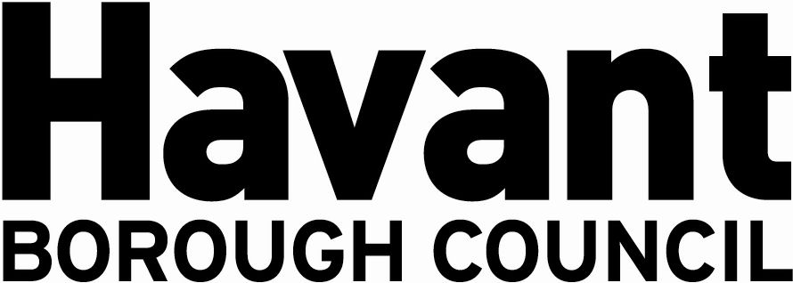

NOTICE OF APPLICATION FOR THE GRANT OF A

PREMISES LICENCE
SECTION 17, LICENSING ACT 2003

I Laura Katie Muir hereby give notice that I have applied on 09 May 2024 to Havant Borough Council as the Licensing Authority for the Grant of a Premises Licence for the premises known as:

Jubilee Park
Waterlooville
Hampshire
PO7 & RE

The application is to enable:
Between the hours of 10:00 to 16:00 Friday - Monday
The sale of alcohol (Both on and off the premises)
Regulated Entertainment (outdoors), namely Live Music, recorded Music and Dance (as specified in the application) to be provided within the Premises.

It is an offence knowingly or recklessly to make a false statement in connection with an application and a person is liable on conviction to a fine not exceeding level five on the standard scale.

Any responsible authority or interested party wishing to make representations on this matter must submit those representations in writing to: LICENSING DEPARTMENT, HAVANT BOROUGH COUNCIL, PUBLIC SERVICE PLAZA, CIVIC CENTRE ROAD, HAVANT, HAMPSHIRE PO9 2AX by 06 June 2024. A register of applications can be inspected at www.havant.gov.uk

This notice must be displayed outside the premises clearly visible from a public place for 28 days starting the day after application is made to the Licensing Authority.

