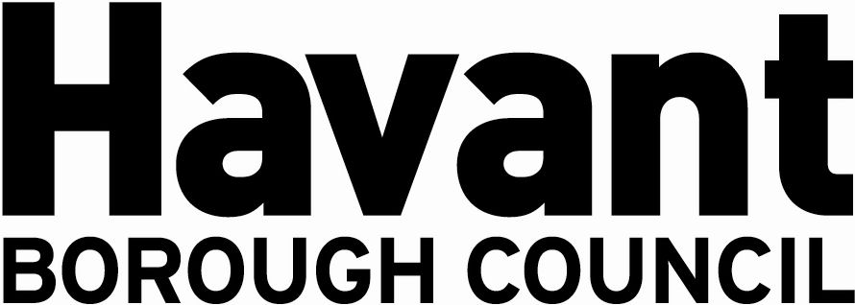

NOTICE OF APPLICATION FOR THE GRANT OF A

PREMISES LICENCE
SECTION 17, LICENSING ACT 2003

We, Country and Coastal Parks 2 Limited, hereby give notice that we have applied on 19th April 2024 to Havant Borough Council as the Licensing Authority for the Grant of a Premises Licence for the premises known as:

The Supermarket,
Hayling Island Holiday Park,
Manor Road,
Hayling Island,
Hampshire PO11 0QS

The application is to enable:

The off sale of alcohol between 08:00 and 22:00 all week.

It is an offence knowingly or recklessly to make a false statement in connection with an application and a person is liable on conviction to a fine not exceeding level five on the standard scale.

Any responsible authority or interested party wishing to make representations on this matter must submit those representations in writing to: LICENSING DEPARTMENT, HAVANT BOROUGH COUNCIL, PUBLIC SERVICE PLAZA, CIVIC CENTRE ROAD, HAVANT, HAMPSHIRE PO9 2AX by 17 May 2024. A register of applications can be inspected at www.havant.gov.uk

This notice must be displayed outside the premises clearly visible from a public place for 28 days starting the day after application is made to the Licensing Authority.

