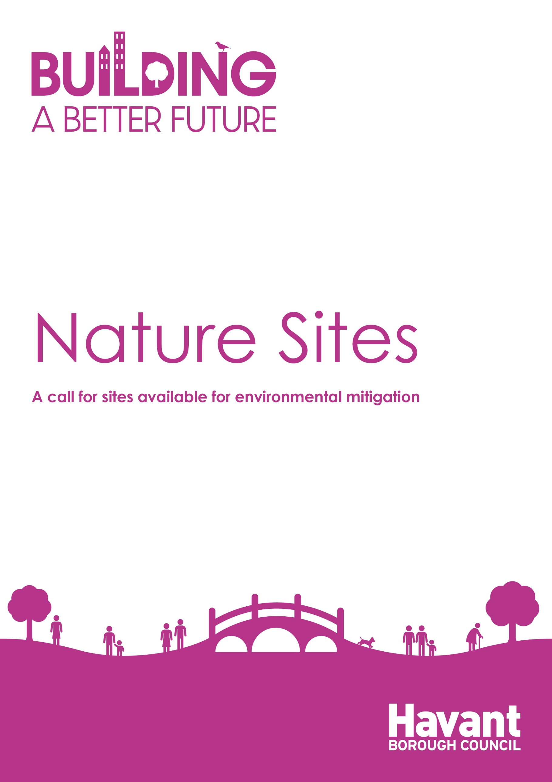

Nature Sites
A call for sites available for environmental mitigation
For internal use only:
Date Received:
Date Acknowledged

The Authority is inviting interested landowners, developers and land managers to put forward possible sites for environmental mitigation in the following areas:
- Solent Wader and Brent Geese Sites
- Nutrient Mitigation
- Biodiversity Net Gain
- Local Green Space
- Nature Conservation
Such sites could be proposed:
- As a standalone site to potentially be used for environmental mitigation purposes
- Linked to a specific development site(s) which are being promoted through the local plan process
We are looking to identify potential projects, ranging from expressions of interest through to well-developed project ideas in putting forward a site to explore further.
Promoted sites will be considered for inclusion in the Local Plan. If appropriate, sites may also be considered for inclusion in relevant Council strategies for the environment.
Please use the following form to submit details of a site that you consider has potential for environmental mitigation. If you need any assistance in completing the form please contact Planning Policy on 02392 446539.
- Please complete the form clearly and legibly.
- One form should be completed for each site.
- Please attach a map clearly showing the precise boundary (in red) of the site that you wish to promote. Potential sites can only be considered if a map is supplied. Please use an appropriate scale (e.g. 1:2,500).
- Please attach the relevant land registry title
Please email completed forms to planning.design@havant.gov.uk by 14 November 2022.
Alternatively you can post your forms to: Planning Policy and Urban Design, Havant Borough Council, Public Service Plaza, Civic Centre Road, Havant, Hants, PO9 2AX.
The information collected in this form will be used by the Council to inform the preparation of the Local Plan, and other supporting documents. For more details on how we will use your information, please view the Council’s privacy notice at: Privacy policy | Havant Borough Council and the Council’s declaration on page 6.

Your Details

Name:
Company/Organisation (if applicable)
Email:

Address:
Postcode:
Telephone Number(s): |  | Mobile
Are you the:
- Landowner
- Developer
- Agent
- Other (please specify)

Ownership

If you are not the landowner, please supply the name(s) and contact details of the owner(s)
If you are not the owner, has the owner(s) given support for the land to be used in this way?
Site Details

Site Address including post code:

Site Area (ha):

Developable Site Area (ha):
Current Land Use(s):

Surrounding Land Use(s):

Availability of access to the site:
Site Details

Potential Type of Environment Mitigation
Please indicate the proposed use for the site and provide further details if known:

For sites proposed for multiple mitigation purposes, please tick the boxes below for all applicable uses.

Solent Wader and Brent Goose Mitigation
Nutrient Mitigation
Biodiversity Net Gain
Other (please specify)
Are there any other additional details you would like to tell us about the site?

When is this site likely to be available for mitigation purposes?

Short term |  | Medium term |  |  | Long term
Are there any known constraints to the use of the site for mitigation? (Physical constraints, ownership factors, access, contamination, special protection area):

Any proposals to overcome constraints:

Any other relevant information:

Declaration

Please read the following disclaimer:

- The information collected in this form will be used by Havant Borough Council to inform the preparation of the Local Plan, and other supporting documents, evidence and strategies. By responding you are accepting that all the information within it could be made available to the public.

- The Council must have a full and complete set of information in order to make a determination on whether land should be allocated in the local plan. This includes information on environmental mitigation. If a site was considered under the now withdrawn Havant Borough Local Plan, there may be commentary on the site within the Inspectors Interim Findings Report. Any identified concerns in the inspectors report must be shown to be able to be overcome in order for any allocation in the new local plan to take place.

- The submission of site details, nor the inclusion in strategies or the local plan does not mean that environmental mitigation sites will automatically be considered suitable during the determination of a planning application.

- Any sites submitted for mitigation of potential development impact on internationally designated nature conservation sites will be subject to consideration through Habitats Regulations Assessments which take place at the local plan and planning application stages.

I understand that any comments submitted in response to this request for sites will be made publicly available by Havant Borough Council and will be identifiable to my name or organisation.

Name (print)
Date

Please return this form to planning.design@havant.gov.uk.

If this won’t be possible you can post your forms to: Planning Policy and Urban Design, Havant Borough Council, Public Service Plaza, Civic Centre Road, Havant, Hants, PO9 2AX.

