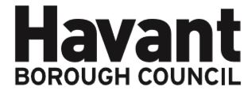

NOTICE OF APPLICATION FOR THE MINOR VARIATION OF A

PREMISES LICENCE UNDER THE LICENSING ACT 2003

I, Vilay Patel, hereby give notice that I have applied on 28.12.2023 to Havant Borough Council as the Licensing Authority for the Minor Variation of a Premises Licence for the premises known as:

Best One - 11 Middle Park Way, Leigh Park, Havant PO9 4AB

The application is to increase the opening hours:

Monday 0530 – 2200 hours
Tuesday – Saturday 0000 – 0000 hours (24 hours)
Sunday 0700 – 2200 hours

It is an offence knowingly or recklessly to make a false statement in connection with an application and a person is liable on conviction to a fine not exceeding level five on the standard scale.

Any interested party wishing to make representations on this matter must submit those representations in writing to: LICENSING DEPARTMENT, HAVANT BOROUGH COUNCIL, PUBLIC SERVICE PLAZA, CIVIC CENTRE ROAD, HAVANT, HAMPSHIRE PO9 2AX by 12.01.2024. A register of applications can be inspected at www.licensing.havant.gov.uk

This notice must be displayed outside the premises clearly visible from a public place for 10 working days starting the day after application is made to the Licensing Authority.

