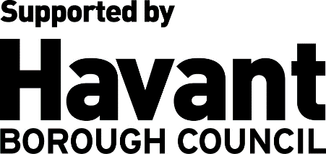

**HAVANT TOWN CENTRE PARTNERSHIP BOARD**

**DRAFT TERMS OF REFERENCE**

1. **The Vision**

To ensure Havant Town Centre continues to be the heart of the town and is a distinctive destination.

Working through a committed inclusive partnership between local businesses, the public sector, voluntary organisations and the wider community, the Board will work collectively to improve the town centre, ensuring it is a vibrant place for residents and visitors to use and enjoy.

1. **Purpose and scope**

The recently adopted [Havant Borough Council Corporate Strategy](https://www.havant.gov.uk/media/8905/download?inline=) sets out ‘**Pride in Place** ***– creating a great place to live work and enjoy’*** as one of the Council’s three strategic priority areas for action. Within this, the establishment of the Havant Town Centre Partnership Board (HTCPB) is a key initiative for Havant Borough Council and partners to take forward to ensure a thriving town centre for Havant.

The Partnership Board is founded on the principles of collaboration and action. The purpose of the HTCPB is to lead in driving forward positive change in the town centre.

The Partnership Board will work collaboratively with retailers, local businesses and the wider community to address some of the challenges currently facing Havant Town Centre.

Working with existing stakeholders the Partnership Board will develop an action plan of community-led initiatives and projects for the town centre. It will look at ways to enhance the quality of the environment, and work with town centre businesses to develop innovative solutions and collective campaigns which strengthen the retail and leisure offer in the town centre.

The Partnership Board will provide place leadership, it will be a key advocate for Havant Town Centre as it moves forward with wider regeneration plans, helping shape a town centre fit for the future.

The Partnership Board will ensure the perspectives, views and feedback of the wider community, including residents, community groups, businesses and other stakeholders, are considered and represented within the activity the Partnership Board takes forward.

1. **Membership**

Membership is open to people who live, work or can demonstrate an interest in Havant Town Centre. Applicants will be able to apply to join the HTCPB through an open and transparent process. Ideally applicants should represent at least one of the groups or stakeholder organisations outlined below and demonstrate good knowledge of Havant Town Centre and some understanding of the challenges faced by Havant Town Centre and other town centres generally. Members will demonstrate a collaborative approach, and a desire to work co-operatively, constructively, and inclusively as part of a team.

The Havant Town Centre Partnership Board will consist of up to 15 members, including the chair and vice chair and will be drawn from the following stakeholders and or interested parties:

• Chairperson - drawn from the private sector

• Vice Chair

• Local Councillors

• Businesses and traders, both tenant and or landlord representatives[1].

• Individual residents and resident group representatives

• Community, voluntary, youth and faith organisations, including those supporting underrepresented groups.

• Local schools’ or colleges representatives

• Community Services representatives

• Community Safety representative

• Transport infrastructure representative

Ex-officio members with non-voting rights

• Council officers – Providing secretariate support

This is a suggested structure in order to provide an optimal and balanced representation across the range of potential stakeholders. The chair reserves the right to deviate from this structure should the need arise.

Havant Borough Council will manage membership enquiries on behalf of the HTCPB. The application process will require applicants to demonstrate their commitment to Havant Town Centre.

The town centre geographical area itself is defined by the Havant Local Plan, and is shown in appendix A.

Membership of the HTCPB will be reviewed annually. If membership falls below eight members, the viability of the HTCPB will be re-considered.

HTCPB members will receive support from the Council to ensure that they understand the role of the Board, the relevant policies and decision-making structures.

1. **Meeting Protocols and Procedures**

A minimum of six meetings of the HTCPB shall be held each year, subject to the agreement of HTCPB members.

For the Board to be quorate at least 4 members will need to be present at meetings. This must include the chair and or the vice chair and at least one other private sector member.

The HTCPB has the ability to call additional meetings should it be deemed necessary by its members, noting that at least seven days advance notice will be required.

If the Chair is unable to attend a meeting, the vice-chair will chair the meeting instead. In the unlikely event neither the chair nor vice-chair can attend, the chair may nominate a substitute from amongst the other board members.

Individual members may decide to nominate a representative to attend in their absence. The nominated representative must fulfil the same Membership criteria as the individual they are sitting in for. The Secretariat needs to be notified at least 48 hours in advance with the names of those attending.

Where matters are agreed to be confidential, members, including any substitutes, are required to treat all such papers and discussion as confidential. Members must not discuss them outside the meeting except with other members of the HTCPB and officers of Havant Borough Council.

Other members of the local community may attend from time to time as observers at the discretion of the HTCPB. This will need to be agreed in advance by the Board.

Meeting minutes of the HTCPB will be open to the wider public unless agreed in advance by Board members.

The names of Board members and, where relevant, the interest group they are representing (such as faith, business or disability) will be published on the council’s website, including where substitutes attend meetings on behalf of a Board member.

All meeting papers and minutes will be published on the Havant Borough Council website.

Havant Borough Council will process the personal data provided by members of the public in their applications to the Board. More information how Havant Borough Council processes personal data can be found on our website www.havant.gov.uk/privacy.

Members will be expected to make the time commitment to the Board, in both attending and preparing for meetings, and undertaking training if required.

A member of the Panel may be removed from office by the Panel by notice in writing if he or she has been absent from meetings of the Panel for a period longer than three consecutive meetings without the Chair’s permission or is unable or unfit to carry out the functions of a member.

1. **Decision-making**

The HTCPB will have a right to make decisions at Board meetings in relation to initiatives/proposals it decides to initiate independently on behalf of the town centre community. Where decisions are to be made, they will be taken by the membership through open votes at meetings. Secret ballots will be held only in exceptional circumstances and where a majority of members indicate this as a preference.

The HTCPB is not a decision-making body regarding projects it has not initiated itself. This includes any project run or managed independently by any member(s) sitting on the Board. It will, however, have the right to request reasonable specific detail or presentations relating to such projects, in order that a joined-up approach to initiatives is maintained.

The HTCPB will have the right, if necessary, to set up sub-committees (or working groups) to work on specific initiatives/projects which will continue to report into the HTCPB. Subgroups can only be created with the approval of HTCPB members and Havant Borough Council.

1. **Code of Conduct & Declarations of Interest**

Members of the Partnership Board will always act in the wider public interest, ensuring accountability, objectivity and transparency in decision-making. Partnership members should be, and be seen to be, impartial in all matters relating to decisions made by the Board.

All members of the HTCPB and any other attendees must work within these Terms of Reference and its Code of Conduct.

Given the remit of the Partnership Board, there may be occasions where conflicts of interest arise. Where conflicts of interest arise Members must declare the nature and extent of any interest, direct or indirect, including but not limited to any personal financial interest.

Meetings must be conducted in a manner that does not exclude any member of the HTCPB.

Members and guests must always maintain a professional attitude during and after meetings.

Members will be expected to be respectful of other people’s opinions and mindful that working within a group can mean that individuals may not always agree with decisions and must accept the responsibility of abiding by majority decisions.

If a member fails to comply with the code, the Chair has the right, following an initial warning, to request the removal of an individual from the HTCPB for gross or persistent breach of the Code of Conduct.

1. **Relationship to Havant Borough Council**

The Partnership Board as an independent body will foster a spirit of collaboration and work in partnership with Havant Borough Council, while maintaining independence. Where appropriate, the Partnership Board will be consulted on Council-led proposals within Havant Town Centre.

The Partnership Board will be responsible for the delivery of community-led initiatives and projects should funding become available to the Board. These will be set out in an agreed action plan, which will be monitored and reviewed on an on-going basis. Proposals must directly relate to and be for the benefit of Havant Town Centre. Members will receive ongoing reports on the progress of any projects, initiatives and/or forthcoming events in the development programme.

Members of the Board will be responsible for letting Havant Borough Council officers know if they are involved with anything that might affect any decision made by the Board.

1. **Equalities, Diversity, and Inclusion**

The HTCPB believes in a fair society that gives everyone an equal chance to learn, work and live free from discrimination, harassment, and prejudice and acknowledges that the diversity of our community is an asset to our borough.

The HTCPB will endeavour to always include a diverse and representative mix of local communities in Havant, including representation from people of different ages, minority ethnic groups, genders, and disabilities.

HTCPB members will recognise the existence and importance of the different lifestyles within our communities and will work to ensure that no group or individual will be directly or indirectly discriminated against.

The HTCPB will ensure no-one is discriminated against based on their age, gender, class, disability, employment status, ethnic or national origins, race or colour, HIV status, marital status, religious or political beliefs, responsibilities for children or dependents, sex, sexuality, trade union activities and unrelated criminal convictions.

1. **Board Support**

Havant Borough Council will provide secretariat support to the Board. It will liaise with the Chair about dates and agendas for meetings.

Promote the meetings with at least seven days’ notice, including an agenda of matters to be discussed, and other supporting materials if required.

Collate agenda items, which need to be raised 14 days in advance to ensure that they can be adequately dealt with at the meeting.

Organise online meetings on Microsoft Teams or a venue for in-person meetings if required.

Take the minutes of the meetings and get these agreed with the Chair and ensure they are issued to members no later than seven working days after each meeting;

Ensure that agreed actions are followed up.

**Appendix A. Town Centre**

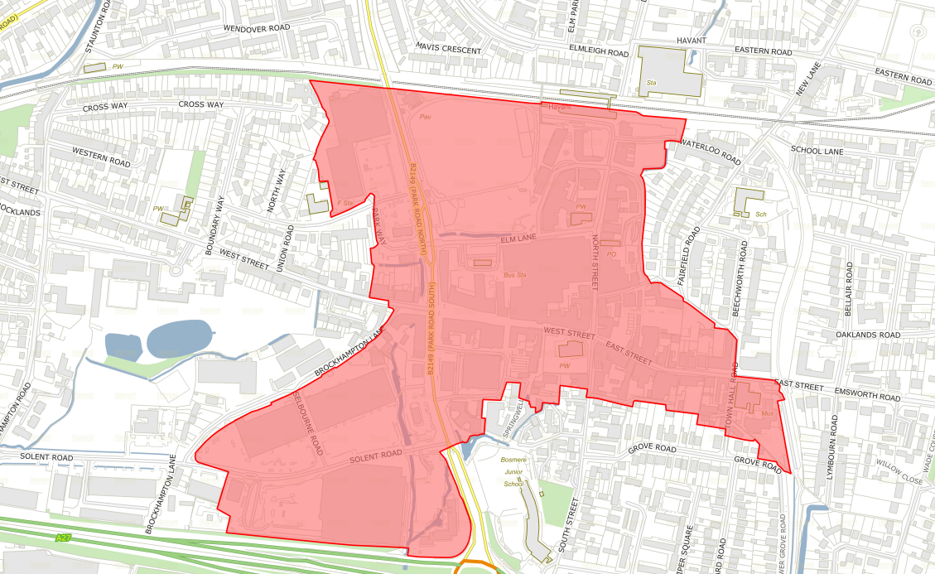

1. Ideally, they should form a representative mix of High Street businesses, and indicatively be drawn from across the following sectors, retail, food & beverage, business and professional services, office tenant.