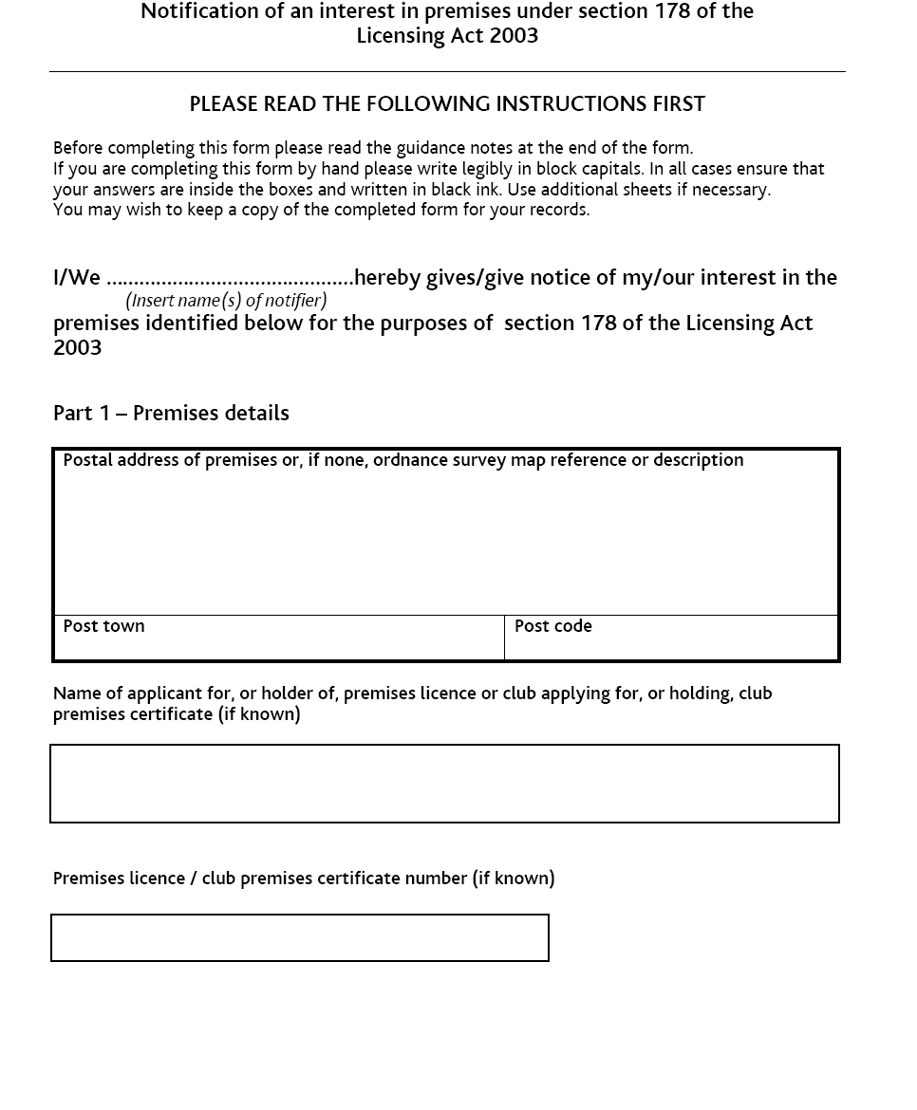
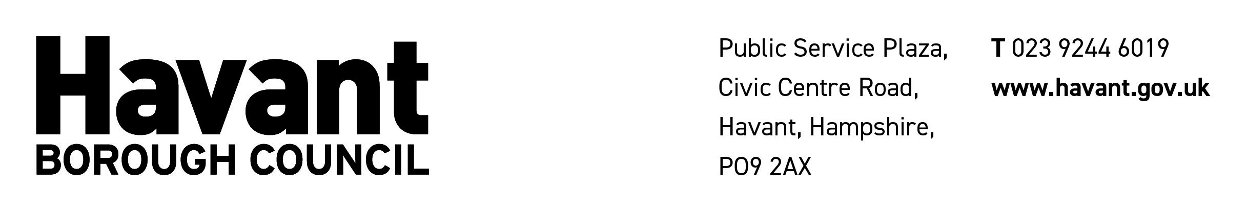
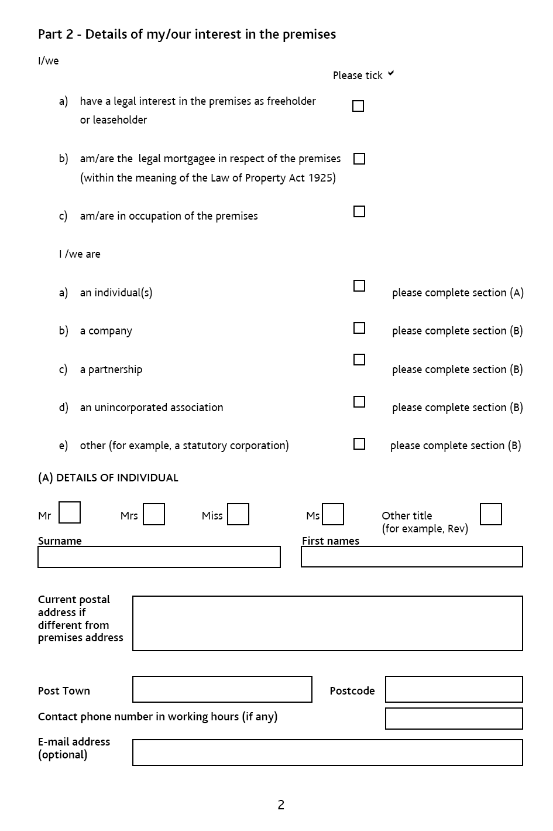

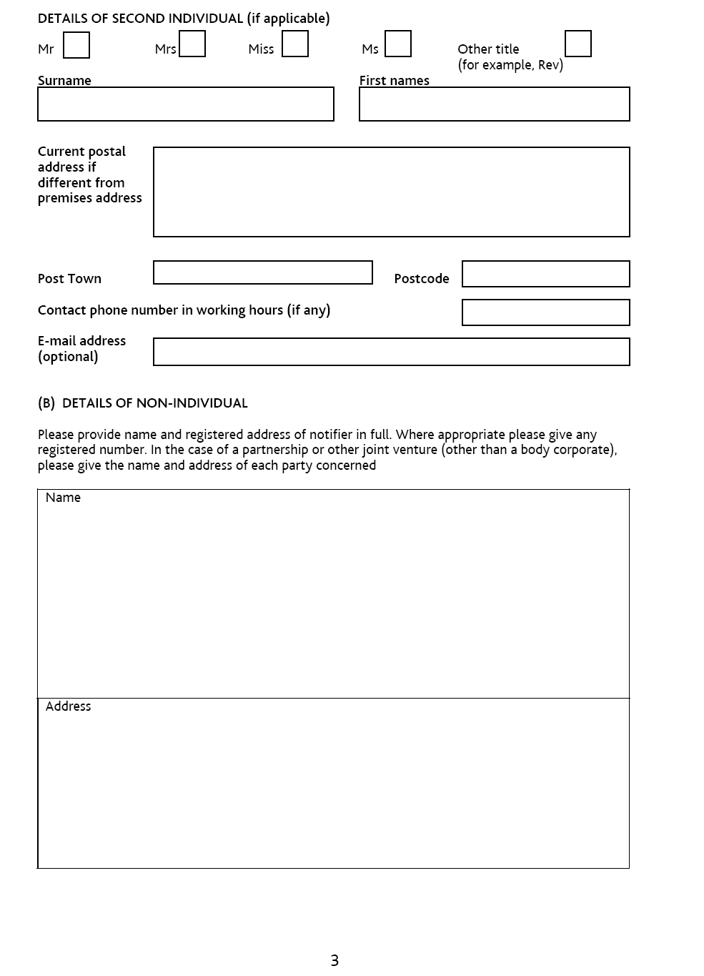

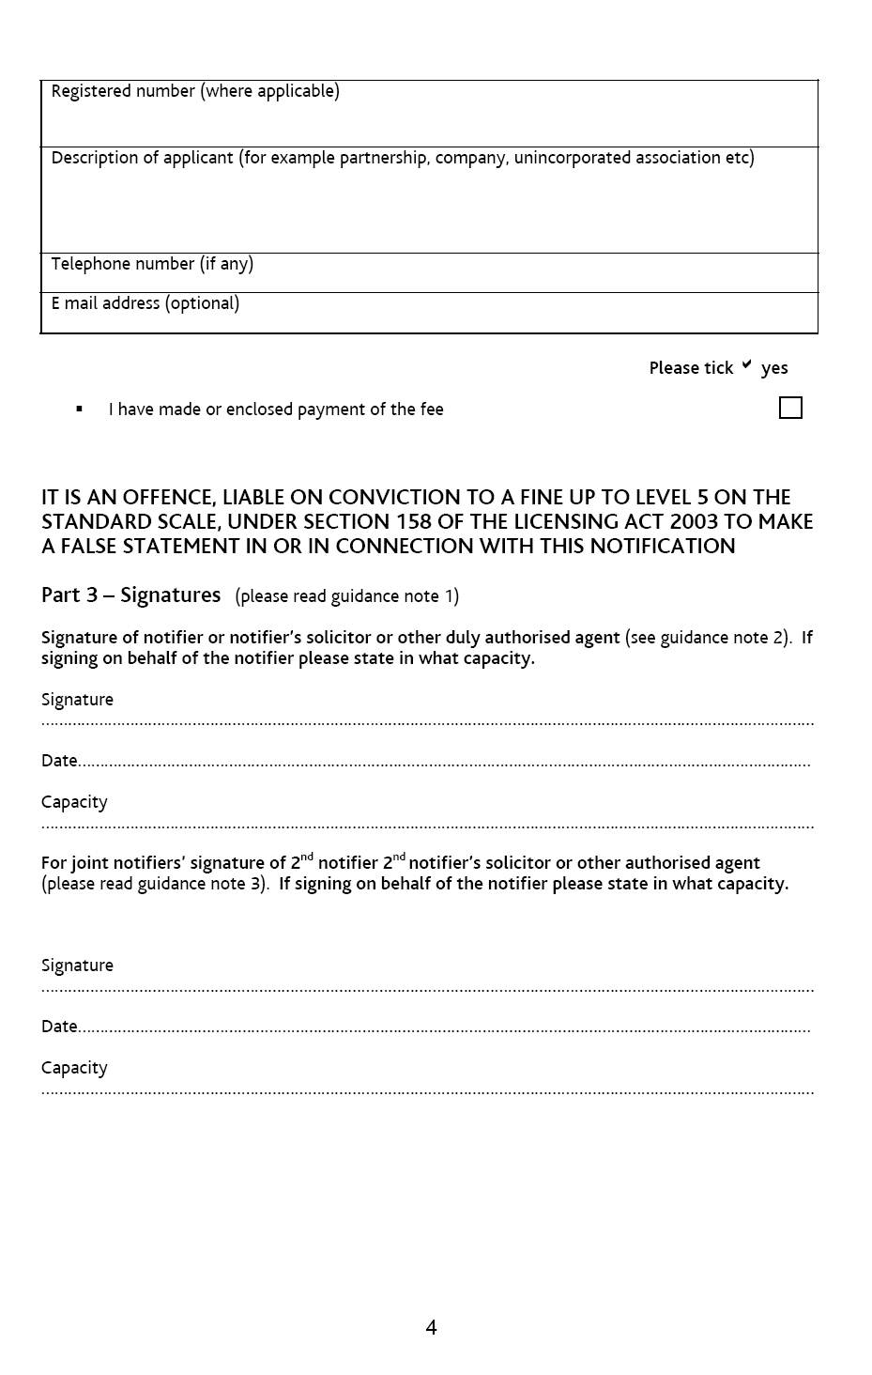

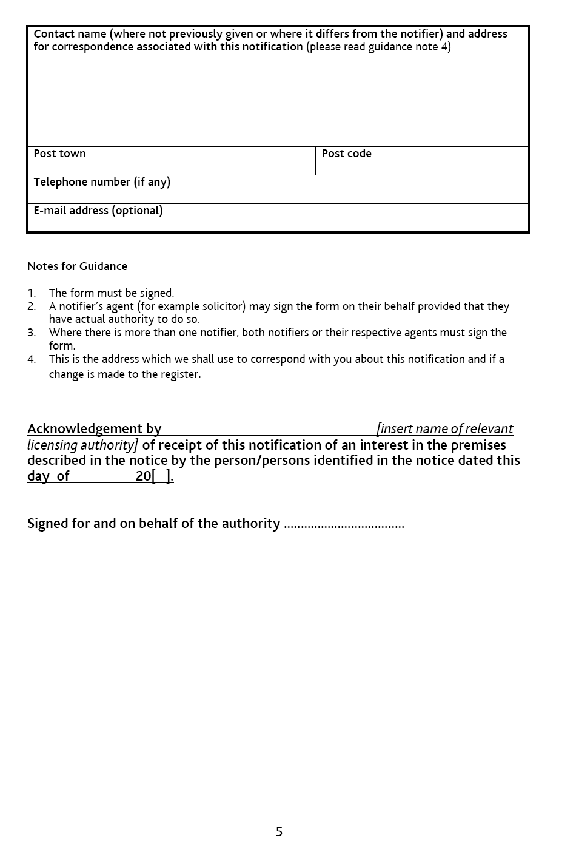

The Council collects information for licensing purposes, but it may be used for any Council's purpose. We may check information that you provide on this form for the prevention or detect or crime/fraud. We may also share this information with other bodies responsible for auditing or administering public funds for these purposes, but will not disclose information about you to anyone outside the Council unless the law permits us to. The Council is registered under the Data Protection Act 1998 for these purposes and is the Data Controller. If you want to know more about what information we have about you, or the way we use this information, please write to the Council's Data Protection Officer.

Additionally, the information provided by you may be shared with our partner local authority East Hampshire District Council as we share senior and specialist staff.

