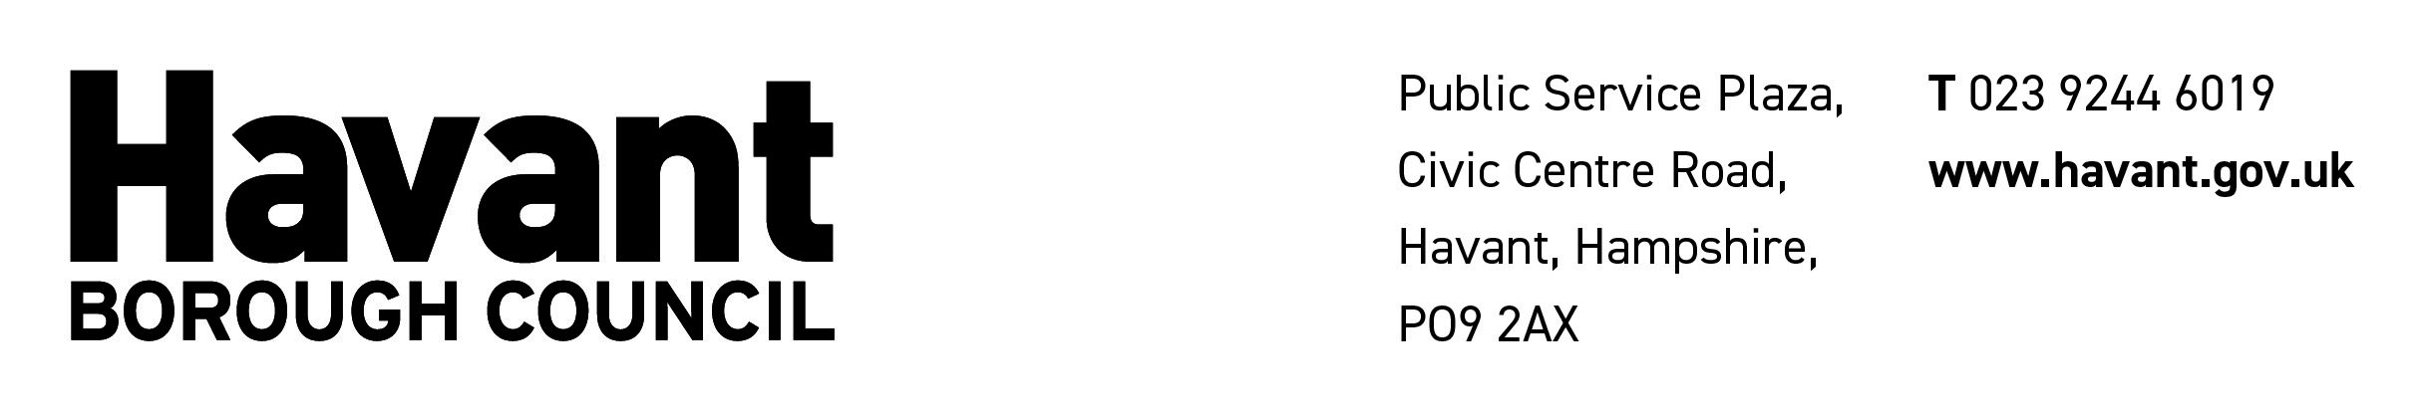

APPLICATION FOR A HOUSE TO HOUSE COLLECTION LICENCE
HOUSE TO HOUSE COLLECTIONS ACT 1939 & HOUSE TO HOUSE COLLECTIONS REGULATIONS 1947 & LOCAL GOVERNMENT ACT 1972

1. Details of Applicant

A. Surname of applicant: (block letters, please) Mr/Mrs/Miss/Ms

B. Other names: Date of birth:

C. Address of applicant: Daytime telephone number:

D. Email of applicant:

2. Details of Organisation of Charity to Benefit

A. Name and address of organisation responsible for making the collection:

B. Name and address of charity or fund which is to benefit from the proceeds of the collection:

Charity registration number:

C. Objects of Charity or fund: (Please enclose recent literature, website address etc, if available).

If 2A and 2B above are not the same, please attach letter authorising you to collect on behalf of the charity/fund.

D. Address to which the licence is to be sent: (Please tick as applicable)

APPLICANT ORGANISATION CHARITY

3. Details of Proposed Collection

Please complete the table below as we require the following information:

Date (start and finish)

Areas where collection is proposed to be held
Number of Collectors

Is it proposed to collect money? | Yes / No
Is it proposed to sell any article? | Yes / No  If Yes, give description or provide examples:
Is it proposed to collect other property? | Yes / No  If Yes, give description of nature and whether it will be sold, given away or used. Please enclose a sample collection bag
Is it proposed to run this collection in conjunction with a street collection? | Yes / No  If Yes, give dates and areas:
Is the collection for a War Charity? | Yes / No  If Yes, state if the charity is registered or exempted from registration under the War Charities Act 1940 and give name of registration authority and date of registration or exemption:

4. Details of Financials

A. Are the whole of the receipts of the collection to be paid to the charity mentioned at 2? YES or NO

B. If no, is it proposed that remuneration should be paid out of the proceeds of the collection to collectors or any other person? YES or NO

C. If yes, please state percentage/£s per day or tonne paid to collectors:

D. If yes, please state percentage/£s per day or tonne paid to charity:

5. Details of Previous Applications and Collections

A. Have you or, to your knowledge, has anyone associated with the collection:

(a) been refused a House to House Collection Licence, exemption order or a Street Collection Permit? YES or NO

(b) had a licence, order or permit revoked? YES or NO

(c) been convicted of any offence under the legislation relating to Public Charitable Collections, the Vagrancy Act 1824 or of any offence of fraud or dishonesty? YES or NO

If YES, give details:

6. Declaration

I undertake to ensure that the provisions of the House to House Collections Act 1939 and the House to House Collections Regulations of 1947 are complied with in connection with the proposed collection.

NB. It may be necessary to request the Police to check your criminal record, as the applicant, in order to ascertain your suitability in accordance with section 2(3)(d) of the House to House Collections Act 1939.

Signature of applicant: __________________________________ Date: ________________

When completed, please return this form to:

Email: licensing@havant.gov.uk

Licensing, Environmental Health, Havant Borough Council, Public Service Plaza, Civic Centre Road, Havant PO9 2AX Telephone 023 9244 6660

Please Note:
- Failure to complete this form in full is likely to result in delay in considering your application.
- No guarantee can be given that any licence will be issued.
- If the person organizing a House to House collection holds an Exemption Order issued by the Secretary of State, do not complete this form but email a copy of the Exemption Order to licensing@havant.gov.uk
- An order form to obtain the required number of Certificates of Authority and Badges from The Stationery Office will be supplied with the Licence.

The information provided by you may be shared with our partner local authority East Hampshire District Council.

