2021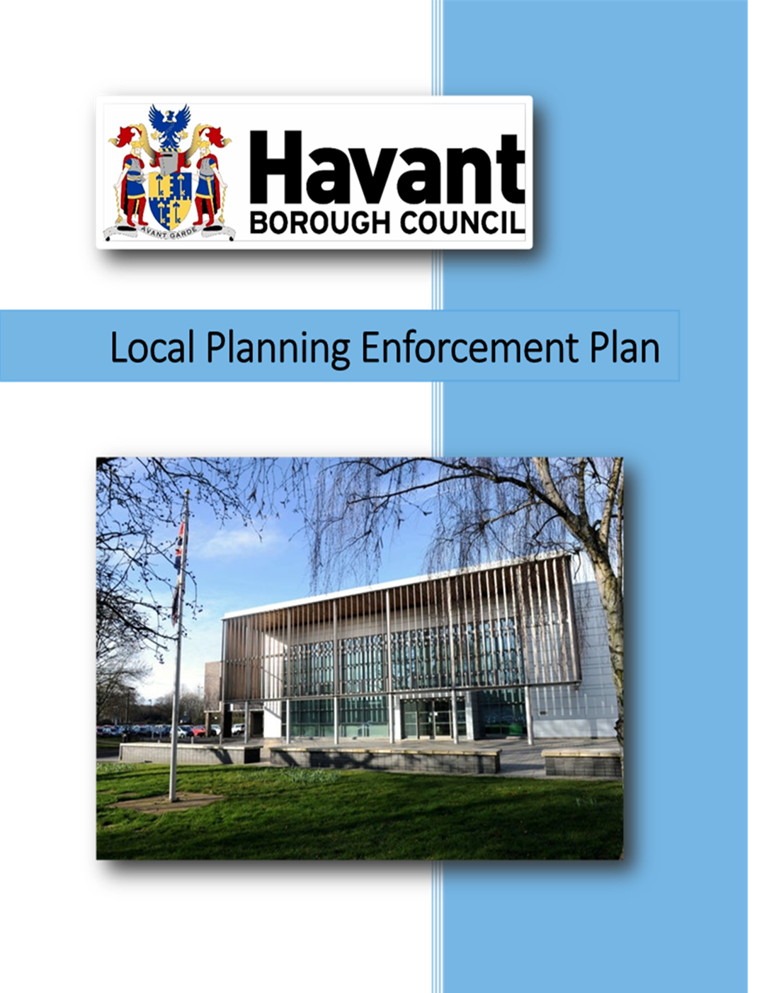

FOREWARD

Vision of the Enforcement strategy
This enforcement strategy upholds our core values of customer focus, environmental sustainability and cost effectiveness.
We will investigate impartially and asses each case on its merits, our decisions will be based upon the principles of Proportionality, Legality and Necessity.
When an offence covered by legislation open to the Local Planning Authority is reported, we will prioritise our response according to the following
* the impact of the offence on vulnerable individuals
* the impact of the offence on amenity or quality of place
* the potential impact on the community as a whole
* other identified need i.e. reputational risk
We will endeavour to investigate matters in a timely manner and maintain contact with interested parties throughout.
Should an offence be proven, decisions whether to prosecute and indeed the nature of the enforcement action will be taken on a case by case basis based upon the principles of Proportionality, Legality and Necessity.

Contents
1. Introduction 4
2. Principles of enforcement 5
3. Legislative background 6
4. How do we prioritise our response? 7
5. How we deal with enquiries 8
6. Planning enforcement flowchart 9
7. Cases needing further investigation 10
8. Retrospective planning permission 10
9. Agreeing an acceptable outcome 10
10. How long will the investigation take? 11
11. What if somebody makes a report about me or my property? 11
12. Enforcement powers 12
13. What happens if Notices are not complied with? 15
14. Investigation standard 16
15. Possible outcomes 16
16. Enforcement register 17
17. Criminal offences 17
18. Interviews Under Caution 18
19. Key principles and conclusion 18
20. Appendix 1 18

- Introduction
  - The Planning Enforcement Plan sets out Havant Borough Council approach to planning enforcement. It provides guidance on the range of options available to achieve objectives of the local plan and address the breaches of planning control in the district.
  - Havant Borough Council recognises the importance of an effective planning enforcement service and has a team of officers assigned to investigate reported breaches of planning control.
  - In Havant Borough Council we place great importance on protecting our environment from the harmful effects of unauthorised development, for all the people who live, work and visit the Borough.
  - The 2021 enforcement plan reflects the changes in legislation and guidance that have emerged since the adoption of the original plan. The Government introduced guidance in the form of the National Planning Policy Framework (NPPF) which came into effect in 2012, then revised in 2018 and again in 2019. In paragraph 58 of the 2019 document it states the following:
‘Effective enforcement is important as a means of maintaining public confidence in the planning system.’ ‘Enforcement action is discretionary, and Local Planning Authorities should act proportionately in responding to suspected breaches of planning control.’

  - Planning is about regulating the use and development of land, regarding the development plan and considering other material considerations. The Local Planning Authority has a duty to investigate allegations of breaches of planning control and it takes this responsibility seriously. In response to enquiries, our aim is for developers to carry out their development in accordance with planning permission and comply with the conditions placed upon the consent.
  - A breach of planning control is where a person carries out development (as defined by section 55 (1) of the Town and Country Planning Act (TCPA) 1990) to land or buildings without the required planning permission, i.e. it is not permitted development, or fails to comply with a condition or limitation of a planning approval.
- Principles of enforcement
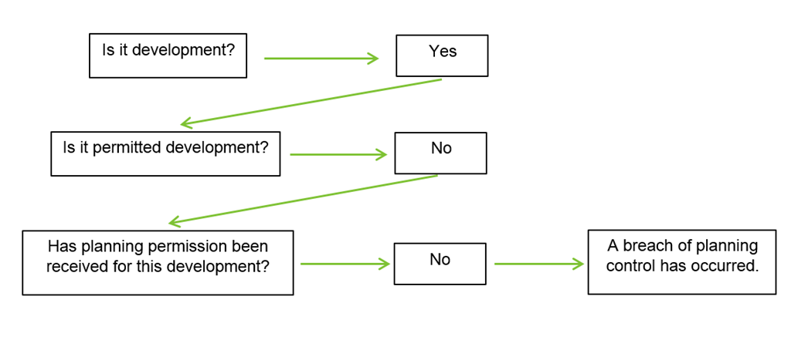
  - We will consider what the most appropriate response is when we investigate enquiries. It may be that matters can be resolved by the co-operation of the customer, submission of a retrospective planning application or by formal action. Should a breach of planning control not be resolved, then we would consider all material considerations and action when it is required. Development that is causing significant harm (priority 1 case) will be prioritised.

  - We will take further action on parties who fail to comply with enforcement notices and actions served by the Local Planning Authority. It is open for the Authority to either prosecute, caution or take direct action and place a charge against the property.
  - Our objective is to act fairly, consistently and transparently when investigating all cases, complying with the General Data Protection Regulations (GDPR).
  - We are happy to discuss cases with all parties with an interest in a case, although there are instances where matters of privacy prevent disclosure. This means no private and confidential information could be released to the public as it is protected under the Data Protection Act 2018. The only time an enquirers information can be made public is if that person would be willing to act as witness an offence and attend in court.
  - We will work alongside people with a view to securing a satisfactory conclusion, including considering the options open to both sides.
  - The council has a duty of care to all its employees and it will not accept its officers being subject to abusive language, threats or unacceptable behaviour.

- Legislative background

  - Planning permission is required for all development and Section 55 of the Town and Country Planning Act 1990 as amended defines development as:
‘The carrying out of building, engineering, mining or other operations in, over or under land, or the making of any material; change in use of any buildings or other land’.
  - Section 171A of the Act defines what a breach of planning control as:
‘The carrying out of a development without the required planning permission, or failing to comply with any condition or limitation subject to which planning permission has been granted.’
  - The exception to the above is development granted by the Town & Country Planning (General Permitted Development) Order 2015 (GPDO) (or any Order amending or replacing this Order). This document outlines certain developments which do not need planning approval from the Council. These developments are given express permission by the GPDO subject to meeting specific criteria and are called ‘Permitted Development’.

  - Most common enforcement enquiries fall into one of 3 categories:
- Development taking place without planning permission (both operational development and material changes of use);
- Development not carried out in accordance with the plans that have been approved;
- Non-compliance with the terms of planning conditions or legal agreements.

  - A limited number of breaches constitute unlawful acts including:
- Non-compliance with an Enforcement Notice:
- Illegal works to a listed building or protected trees
- Illegal display of advertisements.

  - Not all development requires planning permission and a development must be unacceptable in planning terms for the Local Planning Authority to take formal enforcement action. However, works that do require permission must comply with the conditions and regulations set out within that permission. Failure to comply will result in action.
  - Some enquiries received by the Planning Enforcement Team are not covered by planning and/or there may be more effective measures to resolve the enquiry using other legislation. Examples include Land disputes, boundaries, covenants (Civil Action) dangerous structures (building control), noise, smells (environmental health), wildlife habitat destruction (Hampshire Police Wildlife Crime division) and issues on the highway (HCC Highways).

- How do we prioritise our response?
When an enquiry is received it will be allocated a priority status based on the following criteria;
Priority 1: Carry out the initial site visit for priority 1 cases within 1 working day.
- Immediate damage or harm to protected trees and listed buildings/heritage assets where there is potential criminal offence and/or permanent harm.
- Works to/ harm to/ damage to a designated heritage asset (listed buildings and demolition to buildings in a conservation area).
- Work to/ felling/ damage or harm to Tree Preservation Order (TPO) trees or trees in Conservation Areas.
- Unauthorised development that is causing irreparable harm.
- Works likely to be harmful to public health or compromise highway safety.

Priority 2: Carry out the initial site visit for priority 2 cases within 10 days:
- The stationing of new residential caravans in the countryside.
- Commencement of works on major and other developments before the pre-commencement conditions have been discharged.
- Works resulting in landscape harm to sensitive designations.

Priority 3: Carry out the initial site visit for priority 3 cases within 15 working days if necessary following desktop appraisal:
- Untidy sites
- Display of advertisements
- Other breaches of planning control

  - On receipt of an alleged breach the Enforcement Team aim to:
- Register and acknowledge all enquiries within 5 working days
- Carry out the initial site visit for priority 1 cases within 1 working day
- Provide an update at key stages in the investigation and when significant progress has been made.

- How we deal with enquiries
  - Enquiries from the public can be made using the online reporting enquiry form which can be found on the HBC website or via this link. This is the Council’s primary method of reporting alleged breaches of planning control. Additional information, such as photographs of the development, can be sent via email found on the web page.
  - Enquiries can also be made via email, telephone or letter addressed to the Planning Enforcement Team, Havant Borough Council, Public Service Plaza, Civic Centre Road, Havant, PO9 2AX.
  - All enquiries are confidential. However, if the enquiry progressed into a court of law, you may be required to support the Local Planning Authority in providing evidence in relation to a prosecution, only with your express consent to do so.
  - The Local Planning Authority is unable to investigate anonymous enquiries.

- Planning enforcement flowchart

What happens next?
  - Once an enquiry has been received an enforcement officer will be allocated the case. They will then undertake a desk top study of the site, look at the planning history and may visit the site if required, in accordance with the timescale set out in the priorities in paragraph 4 of this plan.
  - If it is found that a breach of planning control has occurred a decision on how to pursue the case will be made and the enquirer updated. If there is no development found or no breach in planning terms, then the case will be closed with the reason for closure recorded.
  - Many of the enquiries we receive reveal that there is in fact no breach of planning taking place. The development taking place may have been granted planning permission or may not have needed planning permission (known as permitted development).
  - In some cases, a breach may occur, however, formal enforcement action isn’t always taken. It may be decided on occasion that planning permission would have be given for the retention of a development or the works are so minor that permission would have been granted without condition. In these examples, no further action would be proposed.
  - Should there be a breach, and the development may be acceptable in planning terms, the person responsible for the breach is normally required to apply for planning permission. This is known as express permission.

- Cases needing further investigation

  - Sometimes an initial site visit is not conclusive, for example when investigating a change of use of land, it can be difficult to establish the use and the impact it is having. Therefore, in some instances repeat inspections may be required.

- Retrospective planning permission
  - Retrospective planning permission is where development has taken place that requires permission and has not obtained it. The Local Planning Authority may request that the owner or occupier to submit a retrospective planning application for the work that has been carried out.
  - Although a local authority may request a planning application to be submitted, it does not mean that planning permission will automatically be granted, and the application will be treated like any application. The planning system allows planning applications to be submitted retrospectively under section 73A of the 1990 Planning Act.
  - If the retrospective application is refused, the local authority may issue an enforcement notice which may require you to remedy the breach of planning control.
  - The Local Planning Authority does not invite the submission of a retrospective application if it is considered that the planning permission is unlikely to be granted, however, the applicant has the right to apply. The only time the applicant’s right is withdrawn is when an Enforcement Notice has already been served against the development that they are putting the application in for. In this scenario planning permission must be sought via the appeal process of the enforcement notice.

- Agreeing an acceptable outcome
  - Where a breach has been discovered and the development is unacceptable the enforcement team will normally try to resolve the matter by discussion. We seek to persuade the person responsible for the breach to either stop development or to modify the development in a manner that is deemed more acceptable. This is often the quickest and most effective way of resolving breaches as formal action can be a lengthy process.
  - If discussions fail or the development is going to have a significant impact on the amenity or environment or it becomes clear to the team that a solution is not going to be achieved, it is then open to the Planning Authority to take formal enforcement action.

- The investigation
  - An investigation can be a time consuming, complex and lengthy process. The time taken to determine each case can vary depending on the site and type of breach that has been reported. The time taken may depend on many factors to which is outlined below:
- Evidence gathering (it can be time consuming to establish a breach)
- Entry to site (restricted access can cause delays)
- Establishing a breach (it can be time consuming to review case law needed to prove a breach)
- Awaiting the submission and/or decision of a planning application or appeal
- Awaiting the compliance of an Enforcement Notice or enforcement appeal
- Lengthy negotiation to resolve planning matters due to circumstances of the case
- Complex legal matters

- What if somebody makes a report about me or my property?

  - If you are contacted by the Council about an alleged breach of planning control you are entitled to know what the allegation is, you will also be given the opportunity to discuss the alleged breach. Your co-operation will be sought to remedy the breach of planning control and a reasonable time may be given for you to comply.

- Enforcement powers
Enforcement Notice
  - An Enforcement Notice will be served against unauthorised operational development, change of use or non-compliance with planning conditions, where the Local Planning Authority is satisfied that the breach has taken place and action is required. The notice is served on the owner, occupier and anybody else who has an interest in the land.
  - The Enforcement Notice will state what steps are required to be taken, including which activities we require to stop, to secure the following outcomes:
- Remedy the breach by making any development comply with the terms (including conditions) of any planning permission which has been granted, by discontinuing any use of land or by restoring the land to its condition before the breach took place, or
- Remedying any harm to amenity caused by the breach.
  - The Enforcement Notice will set out a timetable for compliance, for the steps needed to be taken, starting from the date that the Notice takes effect, which is a date at least 28 days after the notice is served. Any person served with the Notice can use the period between the service of the Notice and the date it comes into effect to appeal to the Planning Inspectorate against the Notice. If an appeal is lodged, the Notice has no effect until the appeal has been determined.
  - There are 7 grounds on which an Enforcement Notice can be appealed:
- That Planning Permission ought to be granted for the works enforced against or if it relates to a breach of a condition that condition should be discharged.
- That the breach claimed has not occurred
- That the matters being enforced against do not constitute a breach of planning control
- That when the notice was served no enforcement action could be taken
- That the Enforcement Notice was not served on all parties with an interest in the land.
- The steps required exceed what is required to remedy the breach or to remedy any injury caused by the unauthorised development.
- The period for compliance falls short of what is reasonably required to be allowed.
  - It is important that the wording of the Enforcement Notice is clear to ensure that any enforcement action taken by the Local Planning Authority can be easily understood. Officers will produce a report, in planning terms, to justify the reasoning for enforcement action. They will take into consideration all material planning considerations i.e. the human rights of those being enforced against.
  - To ascertain the parties who need to be served an Enforcement Notice, a Planning Contravention Notice (PCN) is normally served which also obtains information relevant to the planning breach. A person who is served with a PCN would be subject to a fine of up to £1,000 for failing to complete and return the Notice within 21 days, and a fine of up to £5,000 for knowingly providing false information.
  - The Planning Authority may also serve a Requisition for Information under Section 330 of the Town and Country Planning Act 1990, to require the recipient to set out all parties with an interest in the land, including ownership and occupation details.
Breach of Condition Notice (BCN)
  - If a planning condition has not been complied with, the Local Planning Authority can serve a BCN setting out the steps required to comply with the condition. As with the Enforcement Notice, it does not come into effect for 28 days, however, unlike the Enforcement Notice there is no appeal against the service of the BCN. The current maximum fine in a Magistrates Court for failing to comply with a BCN is up to £2,500.
Stop Notice (Full and Temporary)
  - Where the breach requires the urgent termination of an activity due to it having a serious harmful impact and it is necessary to stop it before the Enforcement Notice comes into effect, a Stop Notice can be served either at the same time as the Enforcement Notice or afterwards. This Notice may remain in effect until the Enforcement Notice comes into effect. Failure to comply with a Stop Notice may result in a fine of up to £20,000 upon conviction in a Magistrates’ Court.
TEMPORARY STOP NOTICE
TOWN AND COUNTRY PLANNING ACT 1990

  - A Temporary Stop Notice can also be served which can halt development for up to 28 days, and can be served before an Enforcement Notice. Consideration can then be taken to serve a Full Stop Notice, once the Enforcement Notice has become effective.
Section 215 Notice
  - Where the amenity of an area is adversely affected by the condition of land or building, the Council can serve a Notice under Section 215 of the Town and Country Planning Act 1990. This Notice sets out the steps necessary to remedy the injury and the time scales for those works to be completed. The Notice may come into effect 28 days after service and anybody served with a Section 215 Notice can appeal it to a Magistrates’ Court.
Planning Enforcement Order
  - In the normal course of events, the Local Planning Authority cannot take enforcement action against operational development or the change of use to a dwelling house after 4 years from the commencement of the breach, or 10 years in the case of other changes of use or non-compliance with conditions. After these periods no formal enforcement action can be taken, and the breach becomes lawful. An owner can apply for a Certificate of Lawful use or Development to establish that a breach is immune from enforcement action. These rights cannot be established if during that period the Council has taken enforcement action.
  - If the breach of planning control has been deliberately concealed then even though the time-period for action may have expired, the Local Planning Authority can, within 6 months of becoming aware of the breach, seek Planning Enforcement Order from the Magistrates’ Court which, if granted, then gives the Local Planning Authority one year to take enforcement action.
  - Immunity from planning control may also be denied following a Supreme Court decision where the person responsible for the deliberate concealment forfeits their right to immunity from planning control, under the ‘Connor Principle’, in that you should not benefit from your wrong doing.
Listed Building Enforcement Notice
  - A notice may be served to require the building to be brought back to its former condition or require other works to alleviate the effects of the unauthorised works.
  - There is a right to appeal against a Listed Building Enforcement Notice.
  - If a Listed Building consent application is granted, the Listed Building Enforcement Notice will cease to have any effect. Listed building consent and planning permission for relevant demolition cannot be granted retrospectively.
High Hedges
  - If a High Hedge complaint is submitted and has followed the correct procedure as outlined in the High Hedges Legislation, we would validate the application and investigate. If we decide that action should be taken to resolve the complaint, we may issue a formal notice to the person responsible for the hedge, setting out what must be done and by when. This action is under the Anti-Social Behaviour Act 2003 and is known as a Remedial Notice. This can include long-term maintenance of the hedge at a lower height. It cannot involve reducing the height of the hedge below 2 metres, or its removal. Although we cannot require such action, the hedge owner is free to go further than what the Remedial Notice requires. The Remedial Notice becomes a charge on the property and legal obligations under such a Notice pass to any subsequent owners.
Signs and Advertisements
  - Where an advertisement is not lawfully displayed and causes harm to the amenity or public safety, and it is considered that express consent would not be granted, the owner/occupier shall be requested to remove the sign. If the sign is not removed voluntarily, the Planning Authority can prosecute or instigate removal. If a person is found guilty of an offence under The Control of Advertisement Regulations he or she could be liable to a fine not exceeding £2,500 per advert. The Local Planning Authority also has the power to serve a Notice requiring the discontinuance of a lawfully displayed advertisement if it is satisfied that it is necessary to do so to remedy a substantial injury to the amenity of the locality or a danger to members of the public. Recipients of a Discontinuance Notice do have a right of appeal.
Protected Trees (TPO’s and trees in a conservation area)
  - It is a criminal offence to undertake works to trees that are subject to a Tree Preservation Order (TPO) or trees within a Conservation Area. It is open for the Council to consider prosecution for unauthorised works to trees protected by a TPO or trees within a Conservation Area.

- What happens if Notices are not complied with?
Prosecution

  - If any of the above Notices are not complied with then the Local Planning Authority usually seek prosecution in the Magistrates’ Court and before embarking upon prosecution, it must be satisfied that there is enough evidence and that prosecution is in the public interest.
  - Failure to comply with Enforcement Notices constitutes a criminal offence. In addition, the carrying out of unauthorised works to Listed Buildings and demolition of unlisted buildings in a conservation area are also criminal offences. Unauthorised works to protected trees and non-protected trees in a conservation area is a criminal offence. There are powers to prosecute persons who illegally display advertisements. The Local Planning Authority has the power to remove/obliterate illegally displayed advertisements in the form of placards and posters.

Direct Action
  - Where the requirements of an Enforcement Notice or a Section 215 Notice has not been complied with, it is open to the Local Planning Authority to enter land and take the steps to remedy the harm and recover from the owner of the land any expenses incurred.

Injunctions
  - Where there is clear evidence that a breach of planning control is anticipated and that the impact of that breach is likely to be serious and cause significant harm, then the Local Planning Authority can apply to the Court for an injunction. This remedy can also be used where an Enforcement Notice is not complied with and where direct action or prosecution would not offer an effective solution.
Proceeds of Crime Act (POCA)
  - Where an operator has benefited financially from unlawful developments and has sufficient achievable assets the Council may seek an application under the POCA legislation to allow for the confiscation of assets equivalent to the value achieved through the unlawful development.

- Investigation standard
  - Should customers not be satisfied with the way an enforcement investigation has been carried out, the matter will be investigated in accordance with Havant Borough Council’s corporate complaints policy. Details of the complaints procedure can be found on the Council’s website by visiting https://www.havant.gov.uk/planning-enforcement-complaint-form

- Possible outcomes

  - Unauthorised development made acceptable with a retrospective planning application. The development has been carried out without the required planning permission, but can be made acceptable by the imposition of planning conditions. The owner/occupier of the land will be invited to submit a planning application to seek to resolve the breach.
  - Unauthorised development unacceptable and immediate remedial action is required:
- Development carried out knowingly that planning permission was required
- The owner/occupier refuses to apply to regularise the breach
- The breach is causing serious harm to public amenity to the local area
- The Local Planning Authority may pursue enforcement action as listed above.
  - No breach of planning control found – development may be permitted or is not within control of planning legislation.
  - Breach of planning control found – may not be expedient to pursue. A breach may have occurred, however, there may be minimal harm. The customer will be advised to seek permission through an application or obtain pre-application advise accordingly.
  - Immune from enforcement action – breach has been in place for a substantial amount of time. Operational development and change of use to a single dwelling house immune after 4 years. Change of use, breach of condition and advertisements immune after 10 years.
  - Lawful Development Certificates – If it is considered that a breach has become immune from enforcement action, the owner/occupier may be able to apply for a Lawful Development Certificate. The certificate would confirm that the breach is lawful for planning purposes.

- Enforcement register
  - The local Planning Authority has a duty to hold and maintain an enforcement register as outlined under TCPA 1990 Section 188.
Notices contained in the register are:
- Enforcement Notices
- Breach of Condition Notices
- Full Stop Notices
- Planning enforcement order
This is a public register and can be found in the reception at Havant Borough Council.

- Criminal offences
  - There are many criminal offences:
- Advertisements- The Town and Country Planning (Control of Advertisements) (England) Regulations 2007 (as amended)
- Tree Preservation Orders (TPO) – The Town and Country Planning (Tree Preservation) (England) Regulations 2012
- Listed Buildings – The Planning (Listed Building and Conservation Areas) Act 1990 (as amended).
- Demolition of buildings in Conservation Areas
- Breaches of notices served

- Interviews Under Caution
  - Under the Criminal Evidence Act 1984 the Local Planning Authority may question suspected offenders. The interview will be audio recorded.

- Key principles and conclusion
This Local Enforcement Plan explains how the Council has responded to government policy on planning enforcement contained in the National Planning Policy Framework (NPPF 2019). It also sets out the procedures for delivering the Council’s Planning Enforcement Service within the available resources.
The Plan is not part of the Statutory Local Plan, but has been agreed by the Council in line with the provisions of the NPPF 2019. This plan and its principles will be considered in all planning enforcement matters.
The Council will continue to seek to improve its Planning Enforcement service by regularly monitoring, reviewing and updating its working practices and procedures, and will continue to look for ways to improve the delivery and the quality of the service.

- Appendix 1
Useful contact details
Postal Address:
Public Service Plaza
Civic Centre Road
Havant
PO9 2AX

Customer Services Telephone: 023 92446019
Email: planning.development@havant.gov.uk
Useful Web Links
Online reporting form: https://www.havant.gov.uk/planning-enforcement-complaint-form
Pre-application advice: Havant Borough Council
https://www.havant.gov.uk/pre-application-advice-service

The National Planning Policy Guidance; gives an overview of planning enforcement:
http://planningguidance.planningportal.gov.uk/blog/guidance/ensuring-effectiveenforcement/ planning-enforcement-overview/
The Planning Portal; basic Information on Permitted Development rights & the ability
to submit a planning application online and guidance:
https://www.planningportal.co.uk/info/200125/do_you_need_permission
Effective Enforcement: https://www.gov.uk/guidance/ensuring-effective-enforcement
High Hedges: https://www.planningportal.co.uk/info/200130/common_projects/29/high_hedges
Section 215 – Best practice guidance: https://www.gov.uk/government/publications/town-and-country-planning-act-1990-section-215-best-practice-guidance
Advertisements: https://www.planningportal.co.uk/info/200130/common_projects/4/adverts_and_signs
Trees: https://www.gov.uk/guidance/tree-preservation-orders-and-trees-in-conservation-areas

