Mkmmm

Havant Borough Council
Emergency Response
Arrangement
2026-2027



Plan ownership
Prepared and owned by | Havant Borough Council (HBC)
Plan Author and reviewing authority | HBC H&S, EPRR Lead.

Document control
Plan version | Date | Remark(s) | Reviewer(s)
3.1 | May 2025 | Scheduled Plan review | HBC H&S & EPRR Lead
3.1 | June - August 2025 | Draft consultation update | HBC Chief Policy Officer
 | August 2025 | Full plan finalised and published | ELT
3.2 | September 2026 | Scheduled Plan review. Changes to link to external document at contents 3.1 | EP Officer

Plan review date.
The plan will be reviewed in September 2027, or sooner if there is a notable change.

Protective marking
This document is granted the protective marking of “OFFICIAL,” however the annexes have been given the protective marking of “OFFICIAL SENSITIVE” as copies will contain personal data of staff (in some cases) and other data or numbers.
This document must be kept secure and must not be transmitted via public e-mail systems or other electronic methods of transfer. It will be made available under the same conditions to those staff requiring access as part of their role. A redacted version of this document can be made public if required.
Resilience Direct (RD) is available to manage viewing, sharing, and storing of these plans securely. The responsibility for this security remains with the nominated LA Administrator for RD.

List of Acronyms
BCM | Business Continuity Management
CBRN | Chemical Biological Radiation Nuclear
CCA | Civil Contingencies Act
COMAH | Control of Major Accident Hazards
CRR | Community Risk Register
DEFRA | Department. of Food and Rural Affairs
EA | Environment Agency
ECC | Emergency Control Centre
EP | Emergency Planning
EPRT | Emergency Planning and Resilience Team
ERA | Emergency Response Arrangements
FCP | Forward Control Point
HCC | Hampshire County Council
HIOW | Hampshire and Isle of Wight
HIWFRS | Hampshire and Isle of Wight Fire and Rescue Service
HSE | Health and Safety Executive
ICP | Incident Control Point
ILO | Incident Liaison Officer
JDM | Joint Decision Model
JESIP | Joint Emergency Services Interoperability Principles
LA | Local Authority
LRF | Local Resilience Forum
NRR | National Risk Register
PPE | Personal Protective Equipment
PRC | Prepared Rest Centre
HBC | Havant Borough Council
RCG | Recovery Coordinating Group
RD | Resilience Direct
RVP | Rendezvous point
SCC | Strategic Co-ordination Centre
SCG | Strategic Coordinating Group
SLA | Service Level Agreement
TCG | Tactical Coordinating Group
UKHSA | United Kingdom Health Security Agency

Contents
Plan ownership……………………………………………………………………………………......2
Document control……………………………………………………………………………………..2
Plan review date………………………………………………………………………………….......2
Protective marking………………………………………………………………………………........2
List of acronyms………………………………………………………………………………………3
Contents……………………………………………………………………………………………….4
Section 1.0 – Background…………………………………………………………………………...7
1.1 Aim…………………………………………………………………………………………….......7
1.2 Objectives…………………………………………………………………………………………7
1.3 Scope………………………………………………………………………………………….......8
1.4 Legislation…………………………………………………………………………………………8
1.5 Command and Control…………………………………………………………………….……..9
1.5.1 M/ETHANE…………………………………………………………………….…………..9
1.5.2 M/ETHANE Message…………………………………………………………………...10
1.5.3 Joint Decision Model (JDM……………………………………………………….…….11
1.6 Risk Assessment………………………………………………………………………………..12
1.7 Business Continuity Management…………………………………………………………….12
1.8 Mutual Aid……………………………………………………………………………………….12
1.9 Data Privacy……………………………………………………………………………………..13
Section 2.0 – Health and Safety…………………………………………………………………...13
2.1 Risk Management Statement………………………………………………………………….13
2.2 On- and Off-Site Management………………………………………………………………...14
2.2.1 Incident Scene…………………………………………………………………………...14
2.2.2. Prepared Rest Centres (PRC)………………………………………………………...15
2.2.3 Emergency Control Centre (ECC)………………………………………………….….15
Section 3.0 - Local Authority Roles and Responsibilities……………………………………….15
3.1 Havant Borough Council…………...…………………………………………………………..16
3.2 Hampshire County Council…………………………………………………………………….18
Section 4.0 - Training and Exercising 21
4.1 Intent to Train……………………………………………………………………………………21
4.2 Training Competencies………………………………………………………………………...21
4.3 Annual Training Schedule…………………………………………………………..………….21
4.4 Exercising………………………………………………………………………………………..21
Section 5.0 – Emergency Control Centre 21
5.1 Activation………………………………………………………………………………………...24
5.2 ECC Set up……………………………………………………………………………………...24
5.2.1 Classic set up……………………………………………………………………...…….24
5.2.2 Modern set up………………………………………………..………………………….24
5.2.3 Virtual set up……………………………………………………………………………..24
5.3 Decision making within the ECC………………………………………………………………25
5.4 ECC Roles……………………………………………………………………………………….25
5.4.1 Gold 25
5.4.2 Silver 26
5.4.3 Link Officer 26
5.4.4 ECC Manager 27
5.4.5 ECC Support Officer 27
5.4.6 Facilitator 27
5.4.7 Incident Liaison Officer 27
5.4.8 Call Operator 27
5.4.9 Loggist 28
5.4.10 Plotter 29
5.4.11 Resilience Direct Officer 29
5.5 Logging in the ECC……………………………………………………………………………..29
5.5.1 Document retention……………………………………………………………………..30
5.6 Financial Costs………………………………………………………………………………….30
5.7 Considerations in the event of a disruptive incident………………………………………...30
Section 6.0 – Warning and Informing 30
Section 7.0 - Recovery 31
APPENDICES 33
Appendix 1 – Briefing Templates…………………………………………………………………..33
A1.1 Template 1 33
A1.2 Template 2 34
Appendix 2 – PRC Map/Locations………………………………………………………………...36
Appendix 3 – Checklists for setting up an ECC………………………………………………….37
A3.1 ECC set-up: Generic step-by-step guide 38
A3.2 Silver briefing sheet: Considerations when setting up ECC 38
A3.3 ECC Manager briefing sheet: Considerations when setting up ECC 39
Appendix 4 – ECC Equipment Checklist………………………………………………………….42
Appendix 5 – Full ECC Layout……………………………………………………………………..43
Small ECC Layout ……………………………………………………………………………..44
Appendix 6 – ECC Role Cards…………………………………………………………………….45
Gold……………..………………………………………………………………………………45
Silver…………………………………………………………………………………………….46
Link Officer ……………………………………………………………………………………..47
ECC Manager and Assistant Manager ……………………………………………………...48
Faciltators……………………………………………………………………………………….49
ECC Support Officer…………………………………………………………………..……….50
Incident Liasion Officer………………………………………………………………………...51
Call Operator ……………………………………………………………………………….….52
Loggist…………………………………………………………………………………………..53
Plotter……………………………………………………………………………………………54
Resilience Direct Officer……………………………………….…………………………...…55
Appendix 7 – Loggist Action Card…………………………………………………………………56
Appendix 8 – Contact Numbers……………………………………………………………………59
Appendix 9 – Phonetic Alphabet…………………………………………………………………..60

SECTION 1.0 - BACKGROUND
This plan sets out the roles and responsibilities of the Havant Borough Council (HBC), and in part the role of Hampshire County Council (HCC), in supporting the Council during an emergency and summarises the function of the Emergency Control Centre (ECC), which is stood up by Havant Borough Council (HBC), when a coordinated response is required across several departments of the council.

Under the Civil Contingencies Act (CCA) 2004, all Local Authorities including District and Borough Councils are Category 1 responders. Emergencies occur and are often dealt with by the responding organisation or emergency service unaided, however, occasionally the nature or severity of the incident will require an integrated approach using other agencies. HBC will be required to support emergency services with resources, consider the welfare of people including shelter and re-housing, warning, and informing the public and protecting the environment.

When the response phase moves to the recovery phase, the Local Authority will take a lead role in recovery activities.

This plan is supported by three guidance handbooks, which can be found on the internal emergency planning webpage these are:
- Handbook A – Emergency Control Centre (ECC)
- Handbook B – Gold Commander
- Handbook C – Silver Commander

1.1 Aim
The aim of this plan and supporting handbooks, is to detail the Council’s emergency response and recovery management framework.

1.2 Objectives
- To outline the roles and responsibilities of both HBC and HCC
- To set out the process for activating and staffing the HBC ECC, including roles within the ECC.
- To outline how the response of the District Council will align with multi-agency response.
- To outline the Training and Exercising schedule for the Council.

1.3 Scope
This plan outlines the roles and responsibilities of the HBC and HCC during a response to an emergency only, including the Single Agency Emergency Control Centre. The Hampshire and Isle of Wight (HIOW) Local Resilience Forum (LRF) Emergency Response Arrangements (ERA) provides an overview of multi-agency response structure, such as the Tactical Coordinating Groups (TCG) and the Strategic Coordinating Group (SCG), and other agency roles and responsibilities.

This plan will refer to a Havant Borough Council (HBC), as a Hampshire lower tier council and Hampshire County Council (HCC), as an upper tier council.

This plan will also refer to HBC’s Emergency Control Centres as "ECCs". Where a reference is made to HCC’s Emergency Centre, this will be specifically referred to as the "County Emergency Control Centre".

1.4 Legislation
The Civil Contingencies Act 2004 (CCA) delivers a single framework for civil protection in the United Kingdom. The Act, and supporting Regulations and statutory guidance, establish a clear set of roles and responsibilities for those involved in emergency preparedness and response at the local level. The act divides local responders into two categories, imposing a different set of duties on each. As a Category 1 responder, Local Authorities are subject to the full set of civil protection duties and are required to:
- Assess the risk of emergencies occurring and use this to inform contingency planning
- Put in place emergency plans. We put in place emergency plans because previous incidents and disasters across the UK, from the Covid outbreak to fuel shortages and severe flooding, have shown that planning for emergencies is essential. We work with the emergency services, NHS, transport and utility companies on plans designed to ensure we respond effectively to emergency incidents and safeguard our communities across the Havant Borough.
- Put in place business continuity management arrangements to ensure key Council services can continue to be delivered
- Put in place arrangements to make information available to the public about civil protection matters and maintain arrangements to warn, inform and advise the public in the event of an emergency
- Share information with other local responders to enhance co-ordination
- Co-operate with other local responders to enhance co-ordination and efficiency
- Provide advice and assistance to businesses and voluntary organisations about business continuity management (local authorities only).
1.5 Command and Control
Under the CCA an emergency is defined as “an event or situation which threatens serious damage to human welfare in a place in the UK; an event or situation which threatens serious damage to the environment of a place in the UK; or war or terrorism which threatens serious damage to the security of the UK”. An emergency may be either a ‘rising tide’ where an incident is predicted (e.g., receipt of a severe weather warning) or a rapid onset incident where the scale and scope of multi-agency involvement is unclear (e.g., a waste site fire or evacuation).

Command, Control and Coordination are important concepts in the multi-agency response to emergencies and there is a distinction between single-agency command and control structures (occasionally termed Gold, Silver, and Bronze) and the multi-agency coordination structures that may be convened at Strategic, Tactical and Operational levels. Please refer to the HIOW LRF Emergency Response Arrangement (ERA) Handbooks for further information on local command and control arrangements and for rising tide and rapid onset response structure diagrams.

In an incident standardised methods of information sharing and briefing should be utilised. For multi-agency incidents, templates for information sharing are available in the HIOW LRF ERA. To support information sharing within the Council an agreed briefing report should be utilised, please refer to Appendix 1 for templates.

Local command and control arrangements are underpinned by the Joint Emergency Services Interoperability Principles (JESIP) which ensures the response is organised, structured, and practiced. Two key JESIP products utilised across HIOW LRF are the M/ETHANE message and the Joint Decision Model (JDM).

1.5.1 M/ETHANE
The M/ETHANE model is an established reporting framework which provides a common structure for responders and their control rooms to share incident information.

It is recommended that this format is used for all incidents and be updated as the incident develops. For incidents falling below the major incident threshold M/ETHANE becomes an ‘ETHANE’ message.

It is important for individuals involved in a multi-agency response to be familiar with the M/ETHANE. Figure 1 on the next page shows the format of a M/ETHANE message.

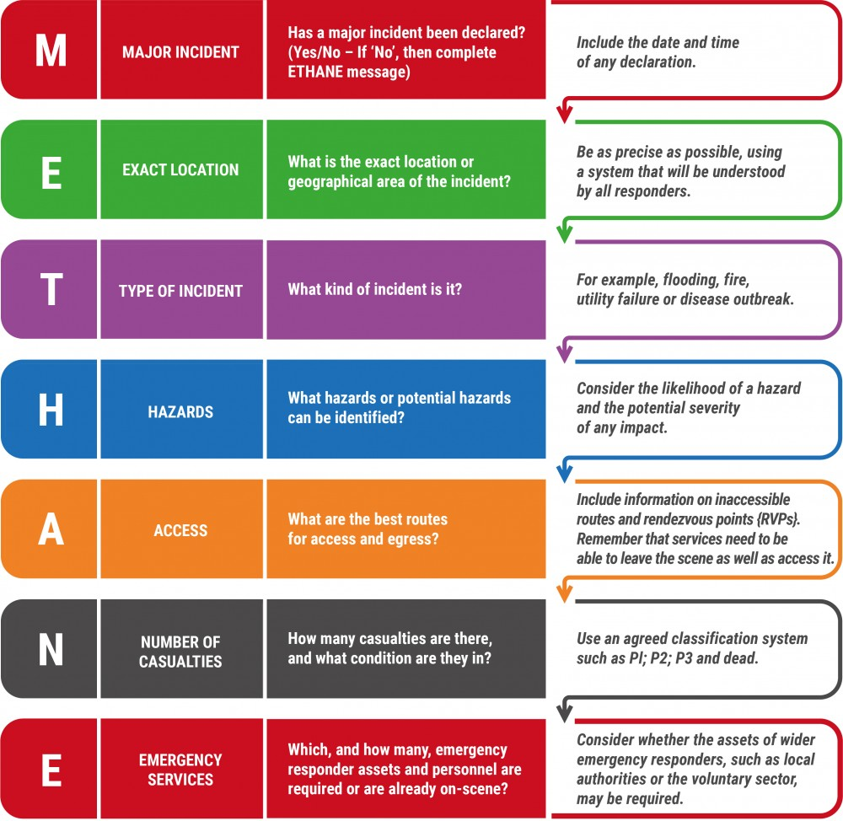
Figure 1. M/ETHANE Message

1.5.2 Joint Decision Model (JDM)
Decision making in an incident follows a general pattern of working out what is going on (situation), establishing what you need to achieve (direction) and deciding what to do about it (action). The Joint Decision Model (JDM), is designed to bring available information from an incident together, reconcile potentially differing priorities and make effective decisions. Figure 2 below shows the JDM which is utilised throughout the HIOW LRF command and control arrangements. The JDM centres around three primary considerations on a continuous loop:
- Working together saving lives, reducing harm
- Gather information and intelligence
- Assess threats and risks and develop a working strategy
- Consider powers, policies and procedures
- Identify options and contingencies
- Act and review what happened.

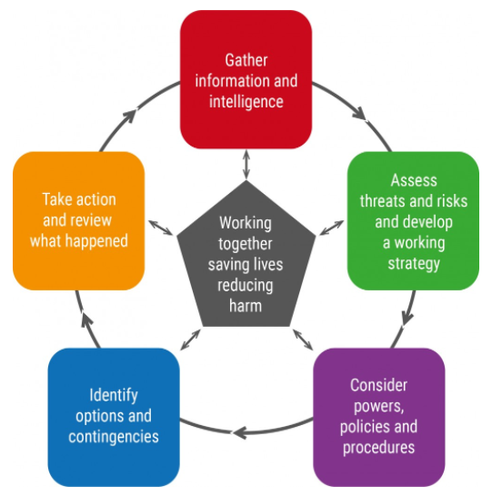
Figure 2. The Joint Decision Model

1.6 Risk Assessment
As a Category 1 responder under the CCA (2004), there is a duty to undertake risk assessments to inform emergency planning and assist with prioritisation of training and exercising.
Nationally, risk assessment is undertaken to produce the National Risk Register (NRR); this is then localised within Hampshire and Isle of Wight (HIOW) Local Resilience Forum (LRF) to create the Community Risk Register (CRR) The official sensitive version is stored on Resilience Direct under risk management and the public version is on the LRF website. The risks included on the National Risk Register (NRR), and subsequently the CRR, are risks that have a wide area impact, such as flooding and pandemics. Local risks are added to the CRR when they produce a significant risk to HIOW area but are not deemed to have enough of an impact nationally for inclusion on the NRR.
At Borough and District level, local risks which are confined geographically within the local authority should also be considered, for example, domestic property fires, gas leaks and localised utility outages. There is an established process within councils to be able to share information on local risks not included in the CRR. HCC EPRT works alongside partner agencies and the HIOW LRF to identify and communicate local risk to the Council.
Local authorities have a responsibility to support emergencies that have an impact on their residents, even on a small scale. It is important that elements of local risk are shared to inform councils of potential hazards that they may encounter. An example of this is the Hayling Island Framework
1.7 Business Continuity Management
Business continuity is an important aspect of planning for any organisation, for a Local Authority these arrangements ensure greater resilience, the capability to manage incidents and the ability to continue providing key services to members of the public. An emergency is likely to impact on the council’s ability to deliver its normal services, as a result Silver will need to assess the impact on normal business and implement Business Continuity Management (BCM) plans where necessary.

1.8 Mutual Aid
A Mutual Aid protocol for the shared use of resources in an emergency has been agreed by all HIOW Local Authorities. This protocol is based on national guidance and is a “non-legally binding agreement.” Those authorities wishing to request mutual aid can do so via their Chief Executive.

1.9 Data Privacy
In an emergency Councils are allowed to share information to support the emergency with other responding organisations. All data sharing should be recorded and a discussion after the incident to resolve how the data is used and stored.
In addition to this, personal data from staff nominated in an emergency planning role, such as contact information, is covered by the following data privacy notice.
Havant Borough Council and Hampshire County Council collects information about you to contact you for support in an emergency response. We will use the information for contacting you to assist in a response for which your work telephone number will be used. The legal basis for our use of this information is to respond under the Civil contingences act (2004). Havant Borough Council will share the contact information with HCC, so the Duty Officer can make contact if required. HCC will keep your personal information for a year, where it will be updated as required. You have some legal rights in respect of the personal information we collect from you. Please see our website Data Protection page for further details. You can contact the County Council’s Data Protection Officer at data.protection@hants.gov.uk.

SECTION 2.0 – HEALTH AND SAFETY
2.1 Risk Management Statement
Risk assessments will form the foundation and basis of all deployments of resources and operations at every level.
The health and safety of all persons committed to working at scenes of incidents, in the ECC, at Prepared rest Centres (PRC) and other emergency locations is of paramount importance. The basic principles of health and safety must be observed, and all personnel must be properly briefed on all hazards and risks associated with their roles and the actions necessary to reduce those risks. A map of the PRCs available can be seen in Appendix 2.
HBC Council employees, acting as Incident Liaison Officers (ILOs), should always wear identifiable high visibility clothing and appropriate Personal Protective Equipment (PPE) when undertaking duties at the scene of an emergency. A dynamic risk assessment should be carried out by the ILO on arrival at the scene. For more information, please see the ILO Incident Logbook, provided to all responding ILOs.

2.2 On- and Off-Site Management
2.2.1 Incident Scene
- At the scene of an incident, responding agencies will implement a cordon to restrict access.
- Inner cordons are seen as high-risk areas and access is strictly controlled. These areas will be clearly marked off e.g., with red, and white striped tape for Hampshire and Isle of Wight Fire and Rescue Service (HIWFRS) or blue and white striped tape for Police.
- Before entering any cordons, permission must be obtained from the lead agency in attendance, safety concerns should be identified, safe working practices employed, and correct Personal Protective Equipment (PPE) used.
- All persons entering cordons will be briefed on the primary hazards, the recognised risks to personnel, the control measures in force and any evacuation arrangements.
- If not fully satisfied with the level of protection afforded to the person seeking entry, that person will not be admitted to the inner cordon. Figure 3 below.
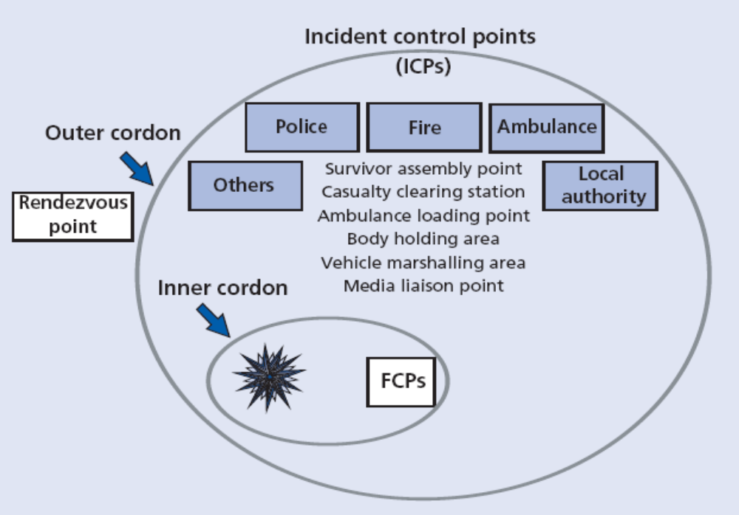
Figure 3 - Scene Management Diagram

2.2.2. Prepared Rest Centres (PRC)
- In a PRC, HCC staff will take the lead in the running of the centre, with support from HBC Officers i.e. Housing Officers.
- Upon arrival, the PRC Manager will undertake a site risk assessment alongside the Building Manager.
- All persons entering a PRC must recognise any hazards, risks to personnel and any evacuation arrangements.
- Staff should consult with the build management to understand any risks or requirements as building users.
- Users of a PRC might be considered as ‘vulnerable.’ If there are any safeguarding or safety concerns these should be escalated to the Rest Centre Manager.
2.2.3 Emergency Control Centre (ECC)
The HBC ECC is in the Public Service Plaza, rooms B120, B119 and B116. In an emergency staff holding meetings in these rooms will need to vacate them.
- In an ECC, the ECC Manager will lead on setting up the ECC, managing staff welfare and take lead in the running of the room.
- All persons entering an ECC must recognise any hazards, risks to personnel and any evacuation arrangements.
- The ECC should also consider any lone or site workers such as those in the PRC or an ILO and keep in regular contact.

SECTION 3.0 - LOCAL AUTHORITY ROLES AND RESPONSIBILITIES
Several local authority services may be called upon to support an emergency. These could be services provided by either the Council or HCC or both. It is important for staff of both tiers of authority to have an awareness of the difference in services they provide in support of an emergency. In cases where an emergency involves more than one council and the incident is of a sufficient scale, consideration will need to be given to the co-ordination of resources supporting operational, tactical, and strategic management. Discussions between the respective authorities involved should take place at the earliest opportunity.
The tasks undertaken by local authorities in support of an emergency response will depend on the characteristics and nature of the emergency. They may include:
Hampshire County Council | Havant Borough Council
Emergency Planning / Control Centres | Emergency Planning / Control Centres
Care and Welfare of the Community:  Short term sheltering (Prepared Rest Centres)  Identification of vulnerable people; Adults and Children’s Social Care | Housing (emergency homelessness):  Emergency accommodation for displaced members of the community following an emergency.  Identification of vulnerable people; other data
Transport / Highways | Town Centre Management
GIS Mapping | GIS Mapping
Countryside Services | Building Control (structural safety services)
Fire and Public Safety | CCTV/Community Safety
Waste Management (disposal) | Waste Management (collection)
Social Care | Parking enforcement
Trading Standards | Street scene services
Flood and Water Management | Land Drainage
Public Health | Environmental Health
Communications | Communications
Managing and restoring critical services | Managing and restoring critical services
Managing emergency finances | Managing emergency finances
Provision of mutual aid | Provision of mutual aid

3.1 Havant Borough Council
The role of the Council may include, but is not limited to, those outlined in the following table.
Service/Department | Key Role
Chief Executives | Provide support to Strategic Co-ordinating Group (in accordance with ERA)  Co-ordinate the council’s response to achieve combined objectives  Maintain Services  Prepare to take over Co-ordinating role  Provide support to Silver  Provision of Mutual Aid and other resources  Securing specialist advice and equipment  Business Continuity Management  Business Continuity Promotion and advice to firms and businesses
Legal Services | Provide legal services
Finance | Provide supportive and advisory role to Chief Executive  Maintain normal services  Establish financial controls  Collate financial expenditure resulting from emergency  Liaise with Government representatives on Bellwin Scheme  Prepare to co-ordinate establishment of an appeal fund  Liaise with insurers and loss adjusters in the event of any claim  Administration of emergency funding schemes
Information Management and Technology | Nominate a telecommunications and IT liaison officer if required.  Establish and support ECC communications and IT, as necessary.  Manage IT for the Council staff and liaison officers from other agencies  Control co-ordinate and allocate existing IT resources  GIS provision
Environment, Environmental Protection and Health Protection Teams | Provide personnel to advise and implement measures to protect life, property and the environment  Enforcement under Acts/Regulations (Food and Environment)  Provide specialist advice and information to the public  Liaise with external agencies as necessary e.g. Dept. of Food and Rural Affairs (DEFRA), Environment Agency (EA), United Kingdom Health Security Agency (UKHSA)  Co-ordinate council’s involvement with animal diseases  Represent the council on multi agency groups in relation to outbreaks of food/waterborne illness and Chemical Biological Radiation Nuclear (CBRN) incidents/spillage of dangerous chemical incidents/toxic release  Flooding  Pollution  Liaise with Health and Safety Executive (HSE)  Pest Control and Street Care  Animal Welfare
Strategic Housing and Landlord Services | Provide facilities, including temporary accommodation for those rendered homeless  Provide practical assistance to those rendered homeless  Prepared Rest Centre liaison  Longer term care and welfare support  Access to specialist transport
Building Control | Co-ordinate and control operations to secure, demolish or repair damaged buildings  Provide advice on the safety of buildings for rescue operations  Secure the services of private contractors as necessary  On-site incident management of site clearance operations in the event of a major emergency
Communications | Council’s Media response  Identify Council’s spokesperson
Customer Service Centre | Dealing with customer enquiries by both personal callers and telephone contact
Councillors | Councillors should keep themselves safe in an emergency like every member of the public and council staff; they must follow instruction from the Emergency Services and not visit an emergency scene, obstruct it or become part of the emergency.  For more information on Councillors roles during an emergency –A councillor’s guide to civil resilience | Local Government Association

3.2 Hampshire County Council
The HCC Corporate Resilience Framework contains details of the specific roles and responsibilities of HCC departments and resources in an emergency. The following table summarises key activities of HCC Services and Departments that may be involved in an emergency response.
Service/Department | Key Role
Emergency Planning and Resilience Team | Provide a 24-hour Duty Officer who will act as the first point of contact for any emergency callout required  Notify the Council of an emergency requiring support
Corporate Operations and Corporate Resources | Legal Services  Information Governance advice  Warning and Informing  Councillor Communications  HR advice/support  IT support  Finance / Financial recording
Adult Services | Identification of vulnerable adults  Support to PRC’s  Community discharge  Welfare assistance as necessary  Long-term service users’ needs
Public Health | Local Authority Public Health
Children Services | Support to PRC’s  Support education staff  School closure information  Identification of vulnerable children
Highways | Maintain highways, including gritting in icy weather, and clearance of obstructions  Assist the police in setting up traffic diversions including signage, road closures  Provide advice and information on highways, drainage and bridges, and surveying and structural matters
Economy Transport and Environment | Provide maps and other geographical information required to support the emergency response  Assist with demolitions and excavations, including drainage
Waste Management | Be responsible for the disposal of oil and chemical waste in the event of a coastal pollution incident  Manage the HCC Recycling facilities across the County
Flood and Water Management | Section 19.0 investigations
Culture Communities Business Support (CCBS) (Countryside, Trading Standards, Property Services) | Advise on issues associated with rights of way  Provide information and advice on farms and business premises situated in Hampshire  Advise on the storage of liquid and solid fuel and explosives  In relation to animal health, make plans for the response to an outbreak of animal disease  Co-ordinate the County response to incidents concerning the contamination of food with reference to the Food and Environmental Protection Act (1985)  Advise on County Council properties that could be used in the emergency

SECTION 4.0 - TRAINING AND EXERCISING
The Civil Contingencies Act (CCA) 2004 (see section 1.5 (m, n), requires the Council to include the provision for carrying out exercises and for training staff or other persons.
The legislation requires the provision of training for all staff who would support emergencies to be included in plans. The training should extend beyond those employed by the responder and include contractors and any other relevant organisations, including voluntary ones, that might be used to support the plan.
Each agency is responsible for ensuring that appropriate training is carried out in accordance with this plan.
4.1 Intent to Train
The Council produces a training schedule to ensure that all relevant members of the authority involved in the response to emergency incidents receive adequate training for their identified role and responsibilities.
Training is carried out to mutually agreed aims and objectives. Records of training delivered will be maintained by the Council.
4.2 Training Competencies
Competence development aims to ensure that each member of staff is enabled to do their job effectively. The competencies are divided into two key areas:
- Management
- Generic
It is the responsibility of the Council to identify suitable individuals for each role based on their skills and expertise and ensure that the individuals attend the relevant training as required.
Anyone who manages staff will need management competencies to be effective within their role. Everyone involved in civil emergency response will be expected to demonstrate and develop core areas, for example, team working, organisational skills, customer care and professionalism. This will be achieved by attending the relevant training modules as listed below in 4.3.
4.3 Annual Training Schedule
The Inter Authority Agreement (IAA), training schedule is in place to support the Council Emergency Response Arrangement and is designed to ensure that District Councils can respond effectively to an incident.
A training syllabus, which includes further information on each module, is available from HBC EP team. Please see the modules that are on offer below:
- Elected Members Training.
- Silver (TCG), and Gold (SCG), Commander Training.
- ECC Manager Training.
- Introduction to Emergency Planning and Emergency Control Centre (ECC) Training.
- Incident Liaison Officer (ILO) Training.
- Loggist Training.
- Resilience Direct Training.

4.4 Exercising
Exercises are an integral part of emergency planning. It is a requirement under the CCA 2004 that a plan includes the provision of carrying out an exercise. Exercises provide an opportunity to test the effectiveness of the plan and for staff to practice their role in an emergency.
Each year the Council Emergency Planning Officer, will produce a scenario of an incident impacting on the Borough that requires an ECC response.
Opportunities to take part in LRF and other multi-agency exercises will arise throughout the year. The IAA, EP Officer and the HBC Health, Safety and EPRR Lead will work together to identify the relevant exercises and individuals to take part in those.

SECTION 5.0 – EMERGENCY CONTROL CENTRE (ECC)
The Emergency Control Centre (ECC) can be a physical or virtual room whereby key people within the Council convene to respond to an incident or emergency at the request of either the Chief Executive, their Deputy, or the Emergency Planning Liaison Officer, in liaison with Hampshire County Council (HCC) Emergency Planning. All individuals are assigned a role (further information on the roles can be found in section 5.4 and Appendix 6) and these will work collaboratively with each other, internal services, and external partners to coordinate the Council’s response to the incident or emergency. Although the below section will suggest a model on how to set up an ECC, please note that it is a scalable model and the way it is set up and the number of key people involved will depend upon the size and severity of the incident or emergency.

5.1 Activation
Local Authority staff may be alerted to an incident and the possible need to respond in several ways, either through:

The HBC Health, Safety and EPRR Lead (acting as the District Link Officer) – following discussion with the GOLD/SILVER Commander.
HCC EPRT – following discussion with GOLD/SILVER Commander.
GOLD/SILVER – Strategic Manager/Management Group.

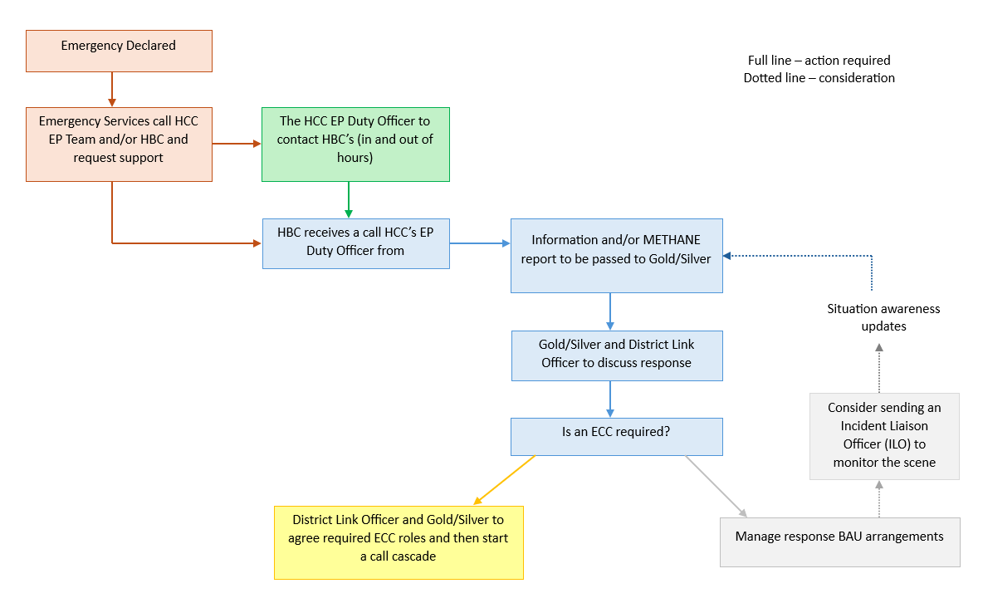
Figure 4 Activation Flowchart

The decision to stand up the ECC is taken by the district itself. This also may be done in consultation with other agencies, for example through a request from the emergency services or HCC EPRT Duty Officer for support.

Other triggers for standing up an ECC include:
- Pre-identified procedures such as flood warnings or activation of specific plans such as Control of Major Accident Hazards (COMAH).
- Volume of calls coming into the Customer Service Centre (e.g., request for assistance).
- The incident requires coordination of several departments within the District Council.

5.2 Emergency Control Centre (ECC) Set up
The ECC is located within the Public Service Plaza (Council Offices). The ECC are rooms B120 - Operational Room, B119 - Gold Command and room B116 for Comms. The rooms ha sufficient space for several staff to be located within the room, several telephone ports are available and has storage cupboards to store specific ECC equipment including whiteboards within the room. The checklist for setting up the ECC, including the equipment required, can be found in Appendix 3.
A scalable model has been designed for the ECC, which usually coincides with the severity of the incident, or the level of response required by the district authority. A smaller ECC (mini ECC), may initially be set up in the event of an incident, which can then be expanded to the full ECC dependent upon the situation. Equally, as the incident begins scaling down, the full ECC can also be scaled back to the smaller ECC. The room layout of the ECC can be found in Appendix 5.
There are three ways in which an ECC can be set-up:
- Classic ECC – paper and co-located
- Modern ECC – technology and co-located
- Virtual ECC – technology and not co-located.
Some emergencies may cause disruption to the way in which the Local Authority operates; the response to the COVID-19 pandemic showed how disruptive an event could be on organisations and society. The timing, extent and severity of disruptive events is unknown however it is important to be prepared for the possibility of responding to an emergency in a different way. Sections 5.2.1 to 5.2.3 below provide an overview of each of the ECC options.
5.2.1 Classic ECC A ‘Classic’ ECC will take place physically in a pre-designated, co-located room and will utilise paper-based systems. Although this type of ECC can be used for any incident or emergency, it will be predominantly used when technology is not available, for example during a power loss or cyber-attack incident.
5.2.2 Modern ECC A ‘Modern’ ECC operates out of a physical pre-designated location utilising technology. This type of ECC can be used for any incident or emergency.
5.2.3 Virtual ECC A ‘Virtual’ ECC is an ECC that utilises technology and is not co-located. This type of ECC can be used for any incident or emergency but specifically for emergencies that hamper staff access to the physical ECC or during an out of hours response where staff are away from the office or at home. Please note that in a ‘Virtual’ ECC, the role of the Plotter will not be required (The role of the Plotter is redundant in a ‘Virtual’ ECC as the information will ‘plot’ itself via MS Planner).

Havant Borough Council Emergency Response Plan Handbook A – Emergency Control Centre provides guidance on how to operate an ECC in each of the three ways outlined above.

5.3 Decision making within the ECC
Due to the fast-paced nature of incidents, decisions need to be made in a timely manner and are based on the information available at the time. Decisions should be taken at the lowest appropriate level, with co-ordination at the highest necessary level. This approach is outlined in the CCA (2004) as Subsidiarity. Decision makers should use tools such as the JDM (Section 1.5.2) to support their conclusions. Decision makers should also ensure that all decisions are logged appropriately (Section 5.5).

There are several roles in an ECC that have the authority to undertake different levels of decision-making. Note that levels of decision-making and the respective roles differ across Councils, therefore the below information is a guide. These are:
- Gold - Overall control of the gold level response, expenditure, resources on a much greater scale if the incident were to escalate
- Silver – Overall control of the silver level response, expenditure, resources
- ECC Manager – Control of the room, responsible for staffing and welfare. Silver Commander can delegate authority if required
- Facilitators - coordinating the response to a specific theme, assigning resources available and exploring where additional resources can be obtained.
5.4 ECC Roles
A summary of the ECC Roles can be found below. Full role cards for all ECC roles can be found in Appendix 6.

5.4.1 Gold
The GOLD level of response is made up of senior personnel able to strategically manage the incident on behalf of the council. They could be based at the Strategic Co-ordination Centre (SCC) if activated or at the council offices if the strategic response is solely limited to one Local Authority. The strategic lead for the Local Authority (GOLD) will delegate the tactical co-ordination of the emergency to a senior manager (SILVER).
The role of the GOLD Team/Officer, if required, is to:
- Formulate the council’s strategic response
- Plan for the Recovery Phase if needed
- Oversee Business Continuity arrangements to maintain critical and where appropriate normal council services
- Ensure financial procedures are implemented in relation to the incident
- Manage Communications to members

5.4.2 Silver
The SILVER Team is made up of specialist personnel from the Council and/or other responding agencies who can provide expert advice in managing and resourcing the emergency response. They plan the operational response and assist, inform, and advise GOLD on the operational response and resources required.

The role, if required, is to carry out the points below, using the Joint Decision-Making Model:
- Implement any strategic policy or directive
- Manage and oversee the operational response
- Determine priorities in allocating resources
- Obtain further resources as required
- Plan and co-ordinate when tasks will be undertaken
- Assess prevailing risks/threats and implement appropriate risk reduction measures

The Silver briefing sheet can be found in Appendix 3.2.

5.4.3 Link Officer
The Link Officer is responsible for administering the call-out of the required resources. They will initiate call-out either personally or through another facility such as a call-centre. The Link Officer may be required to contact the key holder to open the ECC out of hours.

5.4.4 ECC Manager and ECC Assistant Manager
The Emergency Control Centre (ECC) Manager is responsible for the effective management and deployment of the local authority resources, essential to the smooth running of the ECC.

The ECC Manager must ensure the flow of communications are maintained between the ECC and SILVER (and/or GOLD), if operating.

The ECC Assistant Manager will support the ECC Manager and can take over the ECC Manager role within the ECC when the ECC Manager is briefing Silver and/or Gold.

The ECC Manager briefing sheet can be found in Appendix 3.3.

5.4.5 ECC Support Officer
The ECC Support Officer should manage the function of the room and assist the ECC manager and others in the ECC room as required. They should monitor the welfare of the staff in the ECC, including deployed staff such as Incident liaison Officers.

5.4.6 Facilitator
The Facilitators are responsible for managing specific stream elements of the Tactical Emergency Management. There can be as many Facilitators as the Emergency Control Centre (ECC) Manager requires, for roles such as Environmental Health, Housing, Highways etc.

5.4.7 Incident Liaison Officer
Incident Liaison Officers (ILOs) can be deployed to the multi-agency incident command/control point near to the emergency, at rest centres or any other location that may require local authority resources, assistance, or information.
Further information around the health and safety of those deployed to the scene and scene management can be found in Section 2.

5.4.8 Call Operator
Call Operators are responsible for dealing with all incoming calls into the Emergency Control Centre (ECC). Call operators should log all calls on the message pads contained within the ECC documentation.

5.4.9 Logits
Loggists will maintain a running log of the key decisions made by a decision maker when the decision was made and the rationale behind the decision. In some cases, a decision maker may have to write and maintain their own log, however, an available Loggist can be assigned to log for a decision maker. An action card for the Loggist is available in section Appendix 7.

5.4.10 Plotter
Plotters maintains the information displayed around the ECC room, such as maps, Information Board and Action State Board. The plotters must work closely with the Loggists and facilitators to determine key information.

5.4.11 Resilience Direct Officer
The Resilience Direct Officer oversees maintaining the relevant Local Authority Resilience Direct page and, if multi-agency structures are stood up, monitor, and share relevant information with the ECC.

5.5 Logging in the ECC
Key decisions must be recorded to include the rationale for making the decision. A personal log may be maintained by all staff involved with decision making and deployments if required.

It is important that accurate records are kept throughout the period of the response and recovery phase. Accurate records will:
- Serve as a true record of events.
- Function as personal aide-memoire.
- Assist decision making.
- Facilitate handovers of responsibility.
- Provide a health and safety record of personnel.
- Help with advice, warning and informing.
- Aid in the compilation of post operational reports and cost capture.
- Be available for both debriefs and subsequent inquiries.

All requests for assistance and information received within the ECC should be accurately recorded by the plotter, and any decisions taken should be recorded by the Loggist or responsible decision maker.

All meetings of GOLD/SILVER and other groups that may be established must be properly recorded.

5.5.1 Document retention
All documents and records produced during an incident should be stored indefinitely, as a public inquiry may take place many years after an incident where decision makers would be required to account for actions and justify decisions taken. Electronic records should be printed, dated, and stored securely.

5.6 Financial Costs
Responding to an emergency will inevitably entail expenditure over and above normal budgets. It is therefore crucial that all expenditure associated with the response to an incident is clearly identified and recorded. To achieve this, it is important that the Head of Finance is notified at an early stage to establish a dedicated cost centre and financial controls. It may be appropriate for the Head of Finance to form part of the Gold Team.

5.7 Considerations in the event of a disruptive incident
There are some incidents which may cause disruption to the way in which the Local Authority operates. The response to the COVID-19 pandemic showed how disruptive an event could be on organisations and society.

The timing, extent and severity of disruptive events is unknown however it is important to be prepared for the possibility of responding to an incident in a different way to a business-as-usual approach. To support the functioning of the ECC during a disruptive period the following should be considered:

- Complete a risk assessment for the space and its use in line with local policies.

- If you are functioning during a Pandemic, consider the guidance available at the time which may include providing sufficient space between workstations to allow for social distancing to decrease the spread of infection risk, if required consider the use of multiple rooms for the ECC. It will be important to ensure that the ECC is cleaned more frequently during a Pandemic in line with national guidance.

- Consider whether the ECC should be set-up and run physically or virtually depending on the nature and scale of the incident. Please see below several considerations to support running an ECC virtually or as a hybrid:

- Virtual rooms - have a documented process in place on how to set up a virtual or hybrid ECC, including what MS Teams rooms to set up immediately i.e., ECC, Silver, Gold, and Media, and who should be included in what rooms. Ensure the ECC Manager, Silver and Gold have access to all rooms to allow them to transfer between meetings efficiently for regular briefings.
- Use of the chat function – ensure you are using the main ECC room chat function effectively (updating of information and actions) and ensure that all individuals involved in the response (including Silver and Gold) are included in that chat to enable shared situational awareness throughout the duration of the incident. To help with clarity when using the chat use the “@” function to identify who the message is for or add ‘for ECC Manager’ for example. The chat function should NOT replace any action state boards or group/personal logs instead information entered onto the chat function should be recorded on any action state boards/ logs as appropriate.
- Electronic ECC documentation – in the event of a virtual ECC, there may be a requirement for the Plotter to have electronic copies of the action state board, useful information board, clock-in sheet, and contact sheet, that all responders can view and add to simultaneously. This can be done through sites such as SharePoint, please check to see what your organisation has in place. For briefings and action reviews, these electronic documents can then be shared over MS Teams for all ECC staff to see by using the ‘sharing your screen’ functionality.

SECTION 6 – WARNING AND INFORMING
Under the CCA (2004), the local authority has a duty to communicate with the public during an incident; good public communication is vital to the successful handling of an emergency. The media, e.g. Radio, TV, remain the primary means of communication (publishing key messages) with the public in an emergency. However, messaging, and public communications will also be published on social media by the impacted organisations. Organisations should be aware that social media may have high levels of activity.
A communication strategy should be based on the following principles:
- Keep it simple – Information should be clear, brief and memorable.
- Explain – Why it is in their interests to follow advice.
- Be Specific – Individuals need to know what to do, when to do it and where to go.
- Reassure – Avoid using overly alarming language.
- Direct contact – If from a trusted source will be more persuasive. Use multiple sources, including community leaders, to reinforce messages.
- Repeat – Key messages frequently.
- Use a wide range of information mechanisms – Media, leaflets, door to door, websites, social media, and community groups.
- Language – Keep it simple and consider non-English speakers
- Vulnerable people – Should receive the earliest possible warnings and instructions.
In the event of an incident, inter-agency communications will be in accordance with standard operating procedures within and between services and agencies.
You may need to nominate a ‘talking head’ to be the public facing communications lead.
HIOWLRF have a warning and informing plan which aims to provide a coordinated multi-agency communications response to meet the requirements of warning and informing the public in response to, and recovery from, a major incident or emergency within Hampshire and the Isle of Wight. This plan can be found on the HIOWLRF ResilienceDirect page.

SECTION 7 - RECOVERY
Recovery is defined as the process of rebuilding, restoring, and rehabilitating the community following an emergency. The recovery phase begins at the earliest opportunity following the onset of an emergency, running in tandem with the response to the emergency itself.

The local authority will usually coordinate the recovery process following any major emergency and chair the Recovery Coordinating Group (RCG), working closely with other local and regional partners via the HIOW LRF. Several Recovery Working Groups may also be stood up, which require appropriate representation from the District Council and County Council.

The HIOW LRF Community Recovery Plan provides a generic structure for the recovery process. Recovery Guidance to specific incidents can be found under Supporting Documentation on Resilience Direct and in Emergency Response Plans such as HIOW LRF Multi Agency Flood Plan.

Key considerations for the Local Authority are listed below, however, all recovery considerations will differ depending on the impact of the incident.

Short Term Considerations | Long Term Considerations
Welfare | Staff welfare/recognition
Book of Condolence | Business Continuity
Physical and Financial Donations (including Cash donations) | Community support
Security | Audits/ Investigation/ Public Inquiry
Spontaneous Volunteers | Memorials
Business Continuity | Recovery of businesses
Communications | Recovery of tourism
Clean up of the environment | Communications
 | Recovery of infrastructure

APPENDICES
Appendix 1 – Briefing Templates
A1.1 Template 1
The following template should be used alongside the M/ETHANE template.

Issued at |  | Report Number
Contact Number |  | Completed by

REPORTING AREAS | DETAILS
Overview
Location, area affected, scale of incident, affected infrastructure, map location
Weather
Current, forecast conditions, i.e. wind direction and speed
Lead Agency and other agencies involved
Media Arrangements
Media Coordinator (name and contact details)/ Media briefing arrangements
Evacuation and Shelter/ Rest Centre Provision/ Emergency Housing
Transport
Road / Rail closures, diversion routes etc.

Disruption to Utilities and Infrastructure
Distribution, interruptions, restrictions etc.
Community Support/ engagement
Public / Private Water Supplies
Distribution, interruptions, restrictions etc.
Environmental Impact

Affected District Critical Services

A1.2 Template 2
The following template should be used alongside the M/ETHANE template.

 | Key questions and considerations | Notes
I | Information  What, where, when, how, how many, so what, what might? Timeline and history (if applicable), key facts reported using M/ETHANE
I | Intent  Why are we here, what are we trying to achieve? Strategic aim and objectives, joint working strategy
M | Method  How are we going to do it? Command, control and co-ordination arrangements, tactical and operational policy and plans, contingency plans
A | Administration  What is required for effective, efficient, and safe implementation? Identification of others in the room, tasking, timing, decision logs, equipment, dress code, PPE, welfare, food, logistics etc.
R | Risk assessment  What are the relevant risks, and what measures are required to mitigate them? To reflect the JESIP principle of joint understanding of risk. Use the ERICPD hierarchy for risk control as appropriate. Use Decision Controls
C | Communications  How are we going to initiate and maintain communications with all partners and interested parties? Radio call signs, other means of communication, understanding of inter-agency communications, information assessment, media handling and joint media strategy
H | Humanitarian issues  What humanitarian assistance and human rights issues arise or may arise from this event and the response to it? Requirement for humanitarian assistance, information sharing and disclosure, potential impacts on individuals’ Human rights

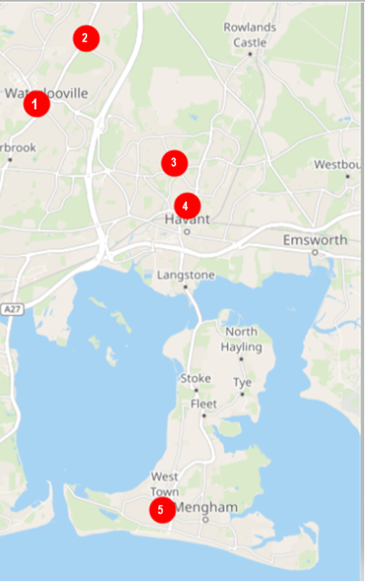
Appendix 2 – Havant Borough PRC Map and Locations

- Waterlooville Community Centre, 10 Maurepas Way, Waterlooville, PO7 7AY
- Cowplain Activity Centre, Padnell Road, Waterlooville PO8 8EH
- Leigh Park Community Centre, Dunsbury Way, Leigh Park, Havant PO9 5BG
- Havant Leisure Centre, Civic Centre Rd, Havant PO9 2AY
- Hayling Island Community Centre, Station Rd, Hayling Island PO11 0HB

Appendix 3 – Checklists for setting up an ECC
A3.1 ECC set-up: Generic step-by-step guide
ECC Set-Up: Generic Step-by-step Guide | Example
Step 1 – On activation of the ECC
- If during working hours, migrate to the ECC in the Public Plaza, Floor 1, Room B120, B119 and B116.
- The Facilities and Resilience Manager will open the building and have access to the equipment cupboard room B120.
- Skip to step 3.
Step 2 – If activated out of hours…
- A call must be made to the Out of Hours -On call Team, who will contact to open the Public Service Plaza if required and the Health, Safety & EPRR Lead or Silver Duty Officer who will attend and open the building and give the equipment cupboard keys.
- If the Health, Safety & EPRR Lead is not available contact the Silver Duty Officer.

Step 3 – Obtaining ECC equipment…
- Retrieve ECC equipment from room B120 and move to the ECC room.
- Items in boxes/ cupboard include can be found in Appendix 4.
Step 4 – Once in the ECC, set up the room according to layout under Appendix 5. Consider…
- The layout of the room including moving of tables and determining which roles will be sat in what seat.
- Set-up the phones – if relevant.
- Ensure all staff are equipped with sufficient stationery and logbooks.
- Place the role cards on the tables where the relevant roles are sat in the room.
Step 5 – Determine ECC roles…
- ECC Manager to retrieve the ECC Manager Briefing Sheet.
- ECC Manager to delegate ECC roles to room so all are aware.
Step 6 – Maintaining the ECC during the response…
- Consider replenishing the Plotter’s state boards when full.
- Ensure Call Operators have enough message forms.
- Consider welfare and refreshment arrangements within ECC throughout the response.

A3.2 Silver briefing sheet: Considerations when setting up ECC
Silver Briefing Sheet: Considerations when setting up ECC | Notes
Initial information required from Activating Officer/Emergency Contact:
- METHANE (or equivalent)/Outline of Incident
- Where (including postcode)?
- When (including timings of any key actions)?
- How many people impacted? (include any specific needs).
- Phone number for ECC/Key officer?
- What are they expecting from you?
Does an ECC need to be considered?
- Who is your ECC Manager?
- Have you contacted the Emergency Planning Lead Officer for support/advice?
- If there is a physical ECC, do you need to be present? Or can issues be escalated virtually?
Do you need an ILO/Is an ILO on scene?
Do you need to bring in any specialist Facilitators from the council?
e.g. Comms, Maps/GIS support, Housing, Waste collection, Environmental Health
Do you need any other resources?
Have you started a logbook?
Remember all decisions you make need to be recorded with their rationale in a timely fashion.
Do you need a loggist to support you?
Brief the ECC Manager of your expectations.
Ensure you have their contact details.
Decide a frequency for briefings.
Do you need to talk to other agencies to get the bigger picture?
Have you got access to documentation on Resilience Direct?
Do you need any information from the HCC EP Duty Officer?
Do you need to attend any multi-Agency meetings? i.e. TCG
Consider what the wider consequences of the incident could be i.e. longer-term housing, pollution issues, comms requirements. Consider Recovery if applicable.
Do you need to discuss/escalate any decisions with Gold?
What communications are happening/ or need to happen?
Do you need to brief any Councillors?
Do you understand what decisions you are able to take/what decisions need to be escalated?
See District Emergency Plan
Consider Debrief of staff
- Following the conclusion of the incident

A3.3 ECC Manager briefing sheet: Considerations when setting up ECC
ECC Manager Briefing Sheet: Considerations when setting up ECC | Notes
Initial information required from activating officer:
- METHANE (or equivalent)/Outline of Incident
- Where (including postcode)?
- When (including timings of any key actions)?
- How many people impacted? (include any specific needs).
- Phone number for person on scene.
- What are they expecting from you?
Do you need to set up an ECC?
- Will this be physical or virtual?
- Do you need any specific equipment?
- If out of hours, do you know how to open the ECC? (add link if required)
Do you need an ILO/Is an ILO on scene?
- Do you have the contact details for the ILO?
- Set a time limit for contacting the ILO for updates and welfare check.
Have you assigned ECC roles? Do they understand the expectations of the roles?
- Loggist
- Plotter
- Call Operator
- ECC Support Officer
- Facilitators
- etc
Do you need to bring in any specialist Facilitators from the council?
e.g. Comms, Maps/GIS support, Housing, Waste collection, Environmental Health
Do you have the contact details of Silver/Gold for escalation of decisions?
Have you started a logbook?
Remember all decisions you make need to be recorded with their rationale in a timely fashion.
Brief the ECC Support Officer of your expectations (if you have one).
Have you provided staff with an initial briefing?
Decide a ‘battle rhythm’/frequency for briefings:
- For ECC
- For Silver/Gold
What welfare arrangements are needed? Assign tasks as required.
- Food/Water
- Shifts
- ILO on scene
- Health and Safety
Do you need to talk to other agencies to get the bigger picture?
Have you got access to documentation on Resilience Direct?
Do you need any information from the HCC EP Duty Officer?
Consider what the wider consequences of the incident could be i.e. longer-term housing, pollution issues, comms requirements. As ECC manager you can ask Facilitators to undertake any key work.
Do you need to discuss/escalate any decisions with Silver/Gold?
Contact comms to make them aware.
Any specific comms requests you have (i.e. Rest centre location, advice lines, lead agency)
Is the ECC running smoothly?
Are messages being recorded and dealt with?
Do you need extra resources?
Do staff understand their role?
Are Action State Boards/Logs up to date?
Have you briefed the ECC recently?
Do you understand what decisions you are able to take/what decisions need to be escalated?
See District Emergency Plan
Consider Debrief of staff
- During hand overs of shifts
- Following the conclusion of the incident

Appendix 4 – ECC Equipment Checklist
Below is a list of key items and pieces of equipment required to set-up and successfully run an ECC:
- Message Trays (one for outgoing message forms / facilitators, one for the ECC Manager’s completion tray)
- Generic Logbooks (Paper incident logbooks.) Digital version saved on the internal Emergency Planning webpage.
- ILO Logbooks
- Printed Role Cards / Briefing Sheets
- Message Forms
- Action State Boards
- Information State Boards
- Contact Details State Boards
- Telephones (for Call Operators use)
- Stationary (pens, pencils, rulers, stapler, blue tack, marker pens / board pens)
- Radios
- Any printed plans (including District Emergency Response Plan)
- Hand Sanitiser(s)
- Spare ILO Kit Bags
- PPE (face masks, hard-wear helmets, hi-vis vests, head torches)
- Spare Digital Camera / Mobile Phone for ILO
Appendix 5 – ECC Layout
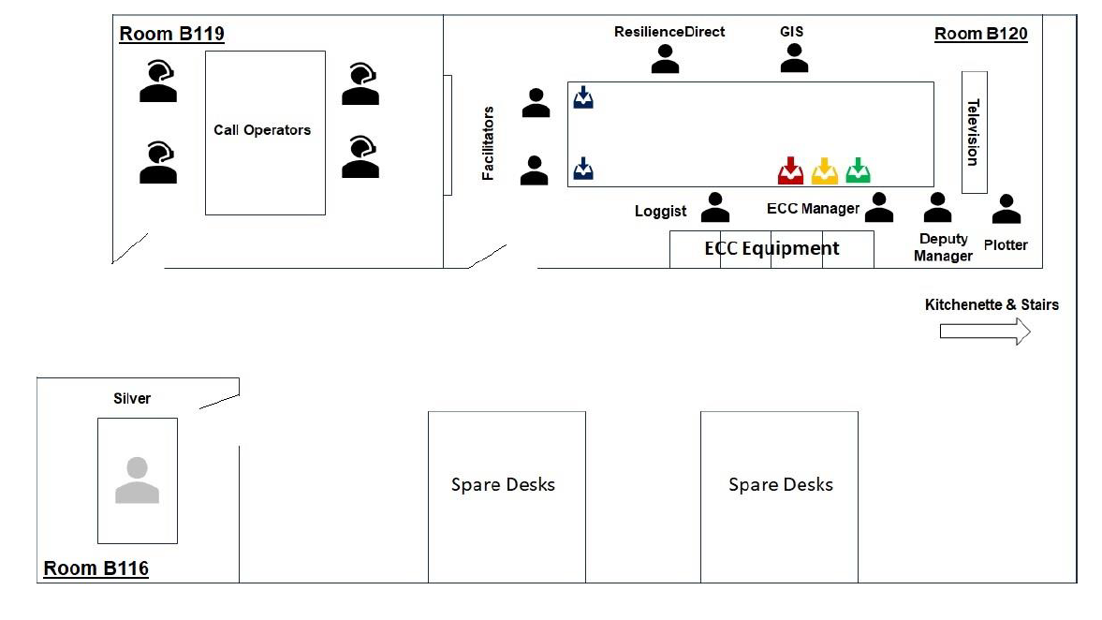

Small ECC Layout
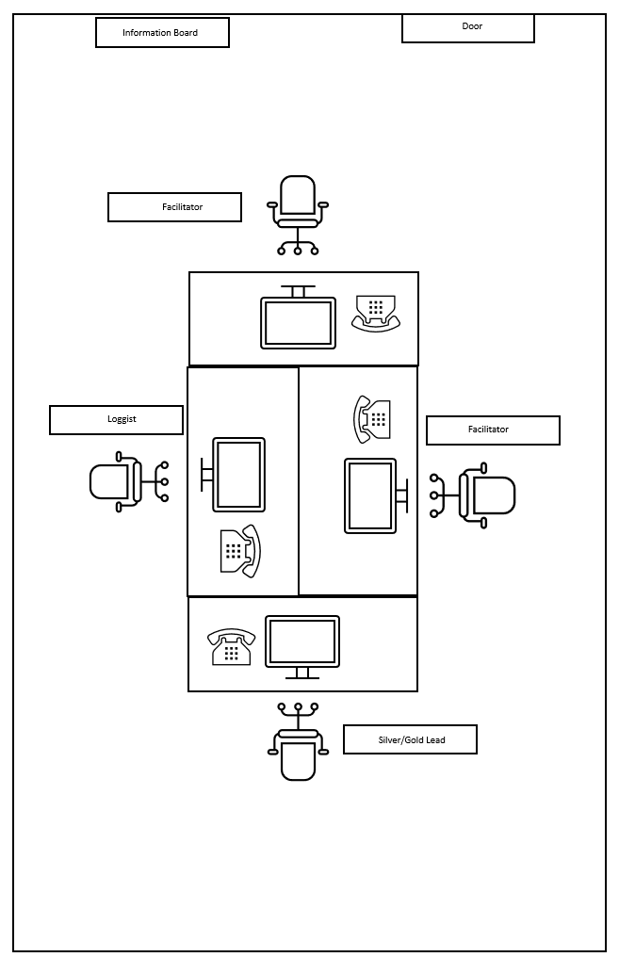

Appendix 6 – ECC Role Cards
GOLD
GOLD will normally be the Chief Executive or other nominated Senior Officer and will be the first to be contacted in an emergency. They are then in charge of the Council’s overall response until they formally hand over command to another officer.
On receipt of a call, GOLD should ascertain the nature and extent of the emergency, and the type of assistance required and if appropriate activate the Gold Team.
On activation of the District Emergency Response Plan by GOLD, it is important that those members of staff who are required to support the emergency are notified immediately.
The first point of contact for GOLD will be the Link Officer who is responsible for administering the call-out of the required resources. They will initiate call-out either personally or through another facility such as a call-centre.
Inform the Link Officer:
- what resources you require to be called into the ECC
- any essential information about the incident e.g. diversion routes
- the contact number they should use to provide updates
- In small scale emergencies the roles of GOLD/SILVER may be combined.
For large, complex or Major Incidents the Multi -Agency Command and Control structures as defined in the HIOW LRF Emergency Response Arrangements (ERA) will be implemented.
The Strategic Co-ordinating Group (SCG) will require all relevant agencies to attend, and GOLD/SILVER will need to decide whether they or a director will represent the Authority.
The SCG level of attendance should be an executive level GOLD/SILVER manager who has the authority to commit finance and resources if required.

SILVER
SILVER will normally be a nominated Senior Officer. They are then in charge of the Council’s tactical level response until they formally hand over command to another officer.
On receipt of a call, SILVER should ascertain the nature and extent of the emergency, and the type of assistance required and if appropriate activate the Gold Team.
The first point of contact for SILVER will be the Link Officer/GOLD/ECC Manager dependant on which point they have been brought into the incident.
Key information to ascertain:
- if the ECC has been set up
- any essential information about the incident e.g. diversion routes
- the contact number they should use to provide updates
- In small scale emergencies the roles of GOLD/SILVER may be combined.
For large, complex or Major Incidents the Multi -Agency Command and Control structures as defined in the HIOW LRF Emergency Response Arrangements (ERA) will be implemented.
The Tactical Co-ordinating Group (TCG) will require all relevant agencies to attend, and SILVER will need to decide whether they or a director will represent the Authority.
The TCG level of attendance should be an executive level GOLD/SILVER manager who has the authority to commit finance and resources if required.

Link Officer
The Link Officer is responsible for administering the call out of the required resources as instructed by GOLD/SILVER. They will initiate call out either personally or through another facility such as a call centre. Call out procedures may include the following:
- If out of hours, check the Facilities Management Team has been contacted to open the Emergency Control Centre (ECC).
- Contact Council ILOs (ILO) to report to the scene of the incident, multi-agency tactical command centres, rest centres etc. as directed initially by GOLD/SILVER.
- Contact Heads of Department as directed by GOLD/SILVER.
- Contact the Council Communications Staff for media and information if required.
- Contact staff for the ECC (ECC Manager, Facilitators, Call Operators, Loggist and Plotters etc.).
- Contact other agencies for ILOs as required.
- Notify HCC Duty Emergency Planning and Resilience Officer.

ECC Manager and Assistant Manager
The Emergency Control Centre (ECC) Manager is responsible for the effective management and deployment of the local authority resources, essential to the smooth running of the ECC.
The role is to:
- When all staff are in place and ready notify GOLD/SILVER and switchboard
- Manage the ECC tactical response
- Maintain their own logbook for key decisions
- Ensure flow of communications are maintained between the ECC and SILVER (and/or GOLD), if operating
- Ensure contact is maintained with Incident Liaison Officers (ILOs) deployed to locations and other local authority resources responding to the emergency.
- Provide regular briefings to the SILVER (and/or GOLD) and ECC staff on the progress of the tactical/operational response
- Ensure that health and safety considerations are applied to council staff and contractors.
Supervise staff and processes in the ECC, paying particular attention to the accurate completion of messages, display boards and logs, ensuring the information flow process is effective
In small scale emergencies the roles of GOLD/SILVER and ECC Manager may be combined.

Facilitators

The Facilitators are responsible for managing specific stream elements of the Tactical Emergency Management and maintaining their own logbook.

There can be as many Facilitators as the Emergency Control Centre (ECC) Manager requires, for example these can include roles for:
- Environmental Health
- Housing
- Highways
- Finance
- Admin
They must ensure:
- Information flow process is being completed for their specific stream by consulting with the Plotter, recording details of actions assigned and completed on message forms.
- Keep the ‘Key Information’ board up to date
- Maintain frequent contact with their relevant council resources responding to the emergency and ensure records are kept of actions and their status
- Conduct regular briefings to the ECC Manager on the overall progress of their specific actions and response
- Manage the ECC when ECC Manager is unavailable

ECC Support Officer
The Support Officer should:
- Set up the Emergency Control Centre (ECC) and distribute equipment
- Ensure staffing and communications are set up in accordance with the ECC requirements
- Ensure staff understand the role(s) required
- When all staff are in place and ready notify the ECC Manager
- Ensure that any multi agency incident control point, police control room, rest centre etc. are notified that the ECC is operational and provide contact details to them
- Be responsible for the welfare of staff in the ECC, including deployed staff e.g. Incident Liaison Officer (ILO)

Incident Liaison Officer
Incident Liaison Officers (ILOs) can be deployed to the multi-agency incident command/control point near to the emergency, at rest centres or any other location that may require local authority resources, assistance, or information. This is a key role in response management and information flow.

The role, if required, includes:
The ILO must be competent in the assistance and knowledge required and must be prepared to conduct a health and safety dynamic risk assessment at the scene of deployment.
An ILO must keep written records of activities conducted in the ILO Logbook.
Get an accurate METHANE (JESIP) brief of the situation from your
GOLD/SILVER including:
Address of the incident | Type and Size of incident
Agencies involved | Evacuation in progress
Hazardous materials | Plume direction
Tactical Command Location / Rendezvous Point | Route Restrictions

Confirm with Emergency Control Centre (ECC) Manager your specific role. Implement your Health and Safety Policy e.g. Lone working, Dynamic Risk Assessment and PPE. At the incident site:
- Keep written records of your activities (Logbook)
- Inform ECC of your arrival at the incident
- Report to Incident Commander at Tactical Command
- Provide ECC with initial situation report (SITREP)
- Represent District Council at Tactical multi agency meetings
- Advise on the authority’s response capability through liaison with the ECC if necessary.
- Maintain information flow between Tactical Command and the ECC

Call Operator
Call Operators are responsible for dealing with all incoming calls into the Emergency Control Centre (ECC). The Call Operator will:
- Ensure the telephones are in place and have been tested
- Obtain message pads and pens
- Answer calls promptly
- Write directly onto message forms to save time
- Write legibly and accurately
- Ensure they record the caller’s name, role (if appropriate), location and telephone number
- Confirm difficult spellings using the phonetic alphabet
- Confirm the information provided and any locations
- Ensure the message is timed and dated
- Ensure the Supervisor collects the message promptly

NB. In the event of an emergency, ‘Main Switchboard Call Operators’, must refer to local arrangements

Loggist
It is important all key decisions are logged with the time they are taken and the rationale. The running log will form the basis for briefings, reviewing decisions, providing feedback and responding to inquiries into the local authority response to the emergency.
The decision to record in a paper-based format or digital format will be a personal preference for the Loggist.
The main source for the log will be the information messages, formal meetings of the Tactical Management Team or when asked to record key decisions by the Emergency Control Centre (ECC) Manager/ Facilitator. The Loggist will:
- Maintain a running log of the key decisions made, when and the rationale behind them
- See Appendix 7 of your District Emergency Plan for a Loggist action card containing best practice.

Plotter
Maps and state/display boards allow key managers to keep track of events and provide an effective briefing tool.
The Plotter will work closely with the Loggist. The Plotter will receive information from the Facilitators. Once the Plotter has dealt with these, they will be passed to the Loggist. The Plotter will:
- Secure maps of the area affected (in most cases these will be provided through GIS systems)
- Keep the map(s) up to date with the latest information on the emergency e.g. the scene(s), affected zones, smoke plumes, diversions and activated Prepared Rest Centres
- Update the state/display boards with important information about the emergency, actions required (together with their status) and tracking the deployment of the local authority resources
Resilience Direct Officer
Maintain the relevant Local Authority Resilience Direct page ​
Monitor and inform the Emergency Control Centre (ECC) Manager of any information shared by multi agency ​
Upload and share any relevant information as directed. ​

Appendix 7 – Loggist Action Card
ACTION CARD - Incident Loggist
Performed by: Anyone (trained as a loggist)
Accountable to: Decision Maker
Responsibilities:
- Identify which decision maker you will be logging for.
- Record and document all decisions and the rationale for the decision made by the decision maker (Paper based logging and/or digital logging)
- Meet with allocated decision maker to agree ways of working.
- Start a decision log, including full names and signatures of Loggist and decision maker.
- Maintain full and accurate decision log.
- Ensure all persons involved in decision process recorded in log.
- Ensure all supporting materials are recorded in the log.
- Follow best practice for Loggists.
- Ensure decision maker signs and dates log, as required.
- Ensure accurate handover notes are produced, and incoming shift are aware of any urgent/outstanding issues.
Best Practice for Loggists
Best practice in record keeping is the gold standard towards which all Loggists should aim, and Judges expect that record keepers will comply with this standard.
A comprehensive record should be kept of all events, information received, decisions, reasoning behind key decisions and actions taken. Each responsible manager should keep his/her own records.
It is important that a nominated information manager be made responsible for overseeing the keeping and storage of the records and files created during the response and for assuring the retention of those that existed before the emergency occurred.
This also applies to logbooks used by on call managers to record issues, information received, and action taken in the normal course of the managers’ work.
The decision to record in a paper-based format or digital format will be a personal preference for the Loggist.
Think C L A – Clear, Legible and Accurate.

- Relevant information should always be recorded in this official logbook. | - Unused spaces at end of a series must be ruled through, signed, dated and timed.
- Make notes in permanent ink. Write legibly. | - Unused spaces at the end of lines must be ruled through with a single line.
- Make notes at the time, or as soon as possible after the event. You may have to | - Crossings out/mistakes must be scored through by a single line and initialled by the maker.
- Use separate pages for each event, incident, or relevant fact. | - Any mistake identified at the time of writing must be scored through with a single line, initialled and the correct word(s) added after the error.
- Ensure you put in date, time (24 hour,) place and people concerned. | - Overwriting or writing above the scored through error is not acceptable. No correction fluid or other correction media must be used.
- Record any non-verbal communication which supports or contradicts spoken comments. | - If a mistake is identified sometime after an entry was made a senior manager should be advised. The mistake should be cross-referred (in red ink) to the corrected entry on the next available page
- Do not assume, comment, or give opinion, unless based on facts. | - Make clear references to relevant exhibits, other documents, maps etc so that it is clear in these notes which exhibit etc is being referred to.
- Entries should be chronological. | - Record all statements, questions, comments and answers in direct speech. Date and time.
- Think No ELBOW –  NO  - Erasures  - Leaves torn out  - Blank spaces – rule them through  - Overwriting  - Writing in any margins | - Each series of entries must be signed, dated, and timed at their close. Loggists making entries over a protracted period should consider signing off their notes at intervals during their period of duty to ensure the integrity of the notes.
Reproduced with kind permission from © D.Burrows-Sutcliffe, TJPettis and CLWallin. 2004.
All rights are reserved.

Appendix 8 – Contact Numbers
The call cascade list is stored separately to the plan.

Appendix 9 – Phonetic Alphabet
Character | Phonetic Alphabet
A | Alpha
B | Bravo
C | Charlie
D | Delta
E | Echo
F | Foxtrot
G | Golf
H | Hotel
I | India
J | Juliet
K | Kilo
L | Lima
M | Mike
N | November
O | Oscar
P | Papa
Q | Quebec
R | Romeo
S | Sierra
T | Tango
U | Uniform
V | Victor
W | Whiskey
X | X-Ray
Y | Yankee
Z | Zulu

END OF PLAN

