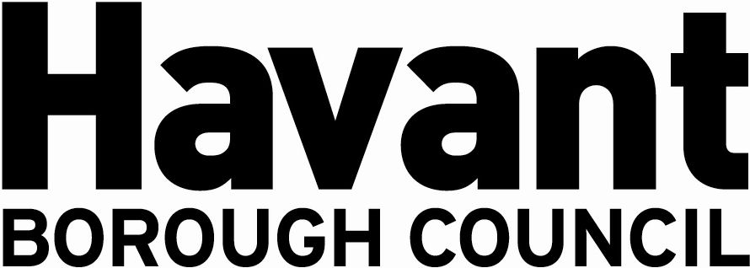

NOTICE OF APPLICATION FOR THE GRANT OF A

PREMISES LICENCE/CLUB PREMISES CERTIFICATE*
SECTION 17, LICENSING ACT 2003

I Emir Demirkol hereby give notice that I have applied on 6th October 2025 to Havant Borough Council as the Licensing Authority for the Grant of a Premises Licence for the premises known as:
USA Fried Chicken, 11 Park Parade, Havant PO9 5AA
The application is to enable:

Late Night Refreshment: 23:00 to 00:00 Sunday to Thursday and 23:00 to 01:00 Friday and Saturday (as specified in the application)

It is an offence knowingly or recklessly to make a false statement in connection with an application and a person is liable on conviction to a fine not exceeding level five on the standard scale.

Any responsible authority or interested party wishing to make representations on this matter must submit those representations in writing to: LICENSING DEPARTMENT, HAVANT BOROUGH COUNCIL, PUBLIC SERVICE PLAZA, CIVIC CENTRE ROAD, HAVANT, HAMPSHIRE PO9 2AX by 03 November 2025. A register of applications can be inspected at www.havant.gov.uk

This notice must be displayed outside the premises clearly visible from a public place for 28 days starting the day after application is made to the Licensing Authority.

Signed____________________________________ Date ______________

