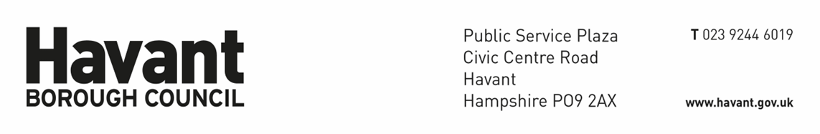
Waterlooville Pop Up Shop EXPRESSION OF INTEREST FORM
Please complete and return your expression of interest form to Economic_Development@havant.gov.uk
This expression of interest stage is to determine whether your proposal is eligible for the Waterlooville Pop Up Shop opportunity.
Applicants will then be scored against set criteria and offered opportunities to launch their business across the year.
You must submit an expression of interest before being invited to progress. The Council will provide a response within two weeks after the submission of your expression of interest and invite you in for an interview.
Expressions of interest may be submitted any time from November 25th 2024.
CRITERIA
- We are encouraging proposals from residents looking to launch their business who are based in the Havant Borough.
- We are encouraging proposals from residents looking to market test their product/service who are based in the Havant Borough.
- Applications are encouraged from businesses offering sustainable products/services.
- Applications from Voluntary, Community and Social Enterprise (VCSE) are welcomed and encouraged.
- Applications that will create new jobs are encouraged.
- Applicants will need to demonstrate a business plan (support is available as part of the application process).
- Applicants will need to be able to trade in the Waterlooville Pop Up Shop across core trading hours, at least Monday-Saturday 9am until 3pm with weekends being priority.
- Applicants will need to have Public Liability Insurance for £5m.
- Applicants will need to be able to sign up to the scheme for a short term licence over the following periods of time:

6 weeks - £550 plus VAT
8 weeks – £650 plus VAT
12 weeks - £1000 plus VAT

- Applications from businesses that pose reputational risk to the council will not be accepted.

YOUR PROPOSAL
Contact name:

Business or Project name:

Name of Directors:

Contact number:

Email address:

PLEASE ANSWER THE FOLLOWING QUESTIONS
- Please outline a summary of the nature of your business. What do you sell? Does it have sustainable or environmental credentials or links to the community? (Limit 500 words)

- What is your previous experience across the Havant borough? Do you have experience of selling your product or service on a high street? Have you had an incubator or ‘pop-up shop’ opportunity before? (Limit 250 words)

- Do you have a business plan with forecasting (Please include with this EOI if you do)? If not will you need start up business support? (Limit 300 words).

- Do you have clear reporting mechanisms and process for sharing data? How will you inform us of success/failure? (Limit 300 words).

- Do you have competition locally and if so, what is your unique selling point (USP)? (Limit 250 words)

- How will you run your pop up shop? How many staff will you have during core trading times? Please describe the day to day running of this (Limit 200 words).

- What does this opportunity mean for your business? (Limit 300 words).

Next steps
Thank you for taking the time to submit your expression of interest.
You should receive confirmation of receipt of you Expression of Interest within 2 working days.

