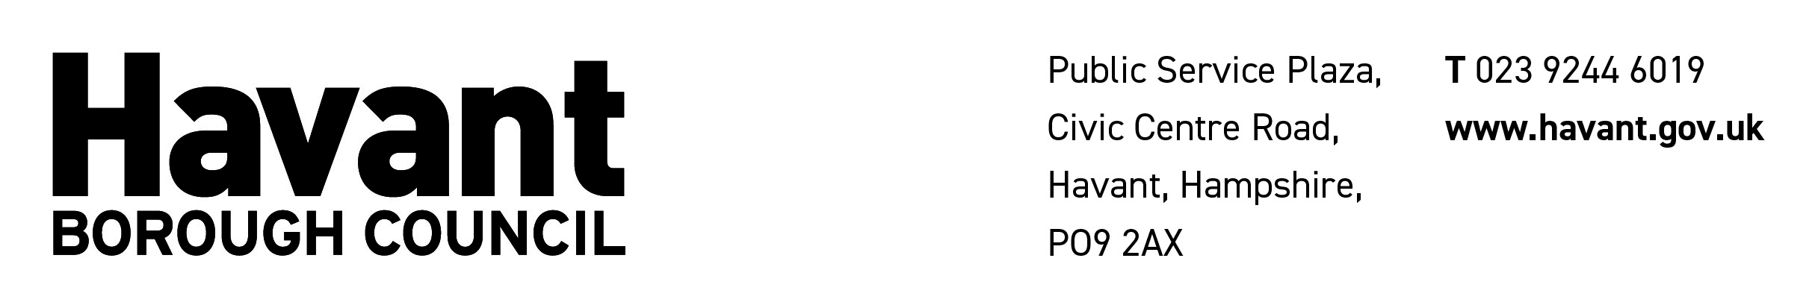

A GUIDE TO HOUSE TO HOUSE COLLECTIONS ACT 1939
& HOUSE TO HOUSE COLLECTIONS REGULATIONS 1947
& LOCAL GOVERNMENT ACT 1972
(AS AMENDED)

The above Act and Regulations contain important provisions for Charitable House to House Collections.

- With the exceptions provided in Paragraphs 3 & 4 below:

No collection for a charitable purpose in any locality may be made unless the promoter is licensed by the Licensing Authority of the area comprising that locality and the collectors are authorised by the promoter.

- Local Authority Licence:

Application for a licence must be made in the prescribed manner. No licence can be granted for a period longer than 12 months. Where a licence is refused or revoked there is a right of appeal to the Secretary of State within 14 days from the date on which notice of the refusal or the revocation is given.

- Secretary of State’s Exemption:

Where the Secretary of State is satisfied that a person pursues a charitable purpose throughout the whole, or substantial part, of England and Wales and will be promoting collections for that purpose, the Secretary of State may by exempt that person from obtaining licences from the Licensing Authority by an Exemption Order.

- Police Certificate:

If the Chief Constable for the Police Area where a collection for a charitable purpose is being, or proposed to be, made is satisfied that the purpose is local in character and that the collection is likely to be completed within a short period, a Certificate in the prescribed form may be granted to the person who appears to be principally concerned in the promotion of the collection; in this instance a licence from the Licensing Authority is not required.

- Requirements of the Legislation:

  - Every promoter of a collection must exercise all due diligence to secure that persons authorised to act as collectors are fit and proper persons and secure compliance by collectors with the Regulations.

  - No promoter of a collection shall permit any person to act as a collector unless that person has been issued;

- A prescribed Certificate of Authority,

- A prescribed Badge,

- If money is to be collected, a collecting box marked or a receipt book (with receipts and counterfoils or duplicates consecutively numbered) marked on every receipt with a general indication of the purpose of the collection and a distinguishing number.

  - In the case of a collection in respect of which a licence has been granted, every prescribed certificate of authority shall be given on a form obtained from The Stationery Office and every prescribed badge shall be so obtained.

  - No persons under the age of 16 years shall act or be authorised to as a collector of money

  - No collector shall pester any person to the annoyance of such person, or remain in or at the door of any house if requested to leave by the occupant.

  - The promoter of a collection must, within 1 month of the expiry of the licence, submit an account of the collection in the form prescribed to the Licensing Authority or Secretary of State, as the case may be.

- Refusals:

The Licensing Authority may refuse to grant a licence if it appears to the authority:

a. that the total amount likely to be applied for charitable purposes as the result of the collection (including any amount already so applied) is inadequate in proportion to the value of the proceeds likely to be received (including any proceeds already received);
b. that remuneration which is excessive in relation to the total amount aforesaid is likely to be, or has been, retained or received out of the proceeds of the collection by any person;
c. that the grant of a licence would be likely to facilitate the commission of an offence under section three of the M1Vagrancy Act 1824, or that an offence under that section has been committed in connection with the collection;
d. that the applicant or the holder of the licence is not a fit and proper person to hold a licence by reason of the fact that he has been convicted in the United Kingdom of any of the offences specified in the Schedule to this Act, or has been convicted in any part of His Majesty’s dominions of any offence conviction for which necessarily involved a finding that he acted fraudulently or dishonestly, or of an offence of a kind the commission of which would be likely to be facilitated by the grant of a licence;
e. that the applicant or the holder of the licence, in promoting a collection in respect of which a licence has been granted to him, has failed to exercise due diligence to secure that persons authorised by him to act as collectors for the purposes of the collection were fit and proper persons, to secure compliance on the part of persons so authorised with the provisions of regulations made under this Act, or to prevent prescribed badges or prescribed certificates of authority being obtained by persons other than persons so authorised; or
f. that the applicant or holder of the licence has refused or neglected to furnish to the authority such information as they may have reasonably required for the purpose of informing themselves as to any of the matters specified in the foregoing paragraphs.
g. that no House to House collection account has been submitted following a previous collection.

7. Definitions:

Charitable Purpose: any charitable, benevolent or philanthropic purpose.
Collection: an appeal to the public, made by means of visits from house to house, to give whether for consideration or not, money or other property.
Collector: a person who makes the appeal in the course of such visits.
Collecting Box: means a box or other receptacle for monetary contributions, securely closed and sealed in such a way that it cannot be broken without breaking the seal.
House: includes a place of business
Proceeds: in relation to a collection, all money and all other property given whether for consideration or not, in response to the appeal.
Promoter: a person who causes others to act as collectors for the purposes of the collection.

