A guide to Volunteering
More people than ever came forward to volunteer during the Coronavirus pandemic, when asked in March 2020 with more than 400+ residents stepping forward to help their Community, local community groups, with new Mutual Aid groups popping up to support. The response was fantastic with local residents and community organisations ensuring that vital services such as food and medications were available to those most in need. We owe a huge THANK YOU to all the residents and groups who helped, no matter how big or small every little task made a difference.
With more charities now resuming activities and looking for volunteers there are new roles appearing every day, the lockdown and restrictions have eased, and will continue to do so but there are still many people in need, and just a few hours a week can make an enormous difference.
We also learnt lots of lessons during the outbreak, and have a suite of information and support available to keep community groups and their volunteers safe, should they be called on again in the future.
Overview of Volunteering: Why volunteer?
Volunteering is simple. It’s about giving your time to do something useful that can benefit both you and your community. Many voluntary organisations would not survive without the time freely given by volunteers.

Benefits of volunteering:
Volunteering can be a great way to:
• Meet new people
• Get some direction and a positive frame of mind
• Develop an interest in new things
• Learn new skills and increase your knowledge
• Have some fun!
• Gain useful experience, training and qualifications
• Give something back to the community
• Develop your CV

How to volunteer safely and links to government guidance on volunteering during the pandemic:
If you would like to volunteer, or coordinate Volunteers in your community but have questions about doing so safely there is plenty of good advice, updated regularly, on both the Government and NCVO websites.
This includes tips on staying safe whilst volunteering such as:

Stay safe when supporting others
- Only volunteer if you feel well enough and are not shielding, self-isolating or in a high-risk group.
- Keep washing your hands often for 20 seconds.
- Stay at least 2m – about three steps – away from people you’re helping. Where 2m is not possible, stay at least 1m apart with precautions.
- If you need to leave home to volunteer, you should be tested twice a week, even if you don’t have symptoms.
- If you’re trying to help someone with very serious issues – don’t be afraid to flag with appropriate statutory services.
- Support family, friends and neighbours by phone or video call.
- Offer to run errands for people but stay outside of people’s homes.
- Let family and friends know what you’re doing.
- Don’t take on too much – it's often better not to offer at all than to let someone down.
Community First #Havant Connects pages offer a range of support and information useful to signposting people for support for specialist advice and guidance with mental health, food and Poverty. There is also a dedicated page for Community groups offering Guidance, Tips and Videos to help organisations and individuals to volunteer safely, and our experienced Volunteer Team, supported by Havant Borough Council, are always on hand to help, they can be contacted at Volunteer@cfirst.org.uk
Key roles for volunteers: What can I do?
There are literally hundreds of different things you can do in all kinds of settings, don’t think that volunteering is just charity shops (although we do have those too)!
Everyone can volunteer and, no matter what your age, background and life experiences, there is an opportunity to suit everyone!

Community First’s Volunteer First currently helps hundreds of charities across Hampshire to advertise their volunteer roles. Volunteering doesn’t have to involve a large time commitment or a long commute either. Many roles are now ‘bitesize’ meaning just an hour or two a week or only occasionally, such as helping at an event or fundraising. Many roles can now also be done from home meaning there’s no need to travel if you’d prefer not to. But if you do need to travel information on staying safe can be found at The Governments- -Safer Travel Guidance

People take up volunteering for a whole variety of reasons for example as an aid to their wellbeing and as a stepping stone to finding the right paid job, particularly if they have been unable to work for a while. Volunteering can inspire your career choices introducing you to things you may never have considered, as well as helping develop important skills and experience.

Whatever your goal, enjoying your volunteering role is important, and it should be a fun and worthwhile way to spend some of your time. Volunteering can also be a way for you to build your confidence and improve your health and wellbeing.

It is as important to think about what you don’t want to do as what you do want to do. You will enjoy it much more and get more out of it if you have found the right role in the right organisation. You may also find that, having gained experience in one sector, you might be able to find work in it, if that is what your end goal is.
For more information and FAQ’s visit our site.

How to access local volunteering opportunities:

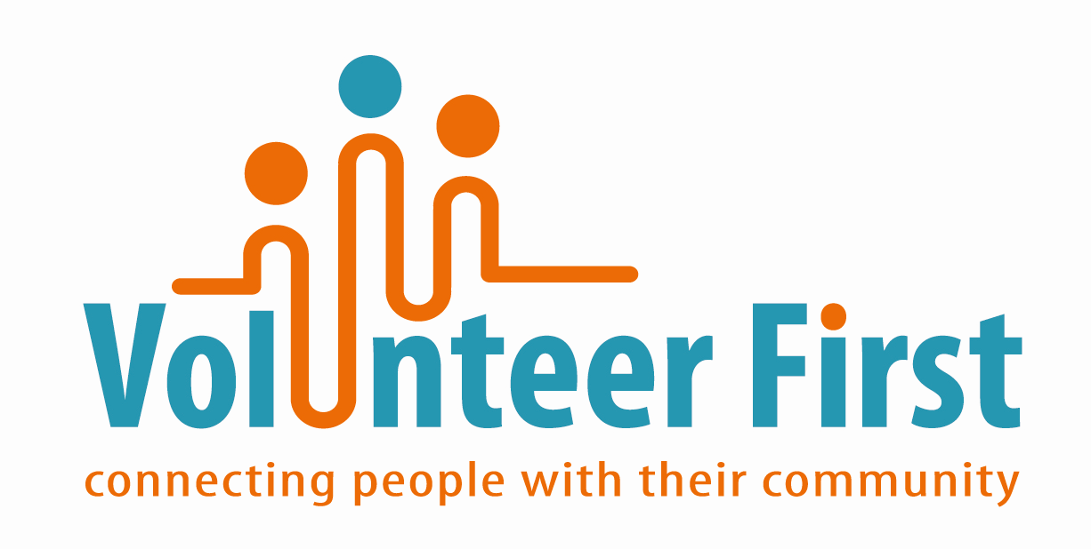
There are a wide range of roles on our Volunteer First website and you can search by interest, activity or distance from your postcode. If there's anything you like the look of you can apply directly online by clicking ‘Register my Interest’ for any opportunity.

Top Tip: When searching online it can be helpful to use the ‘Keyword’ box to look for areas of interest i.e. driving or office work. You can also search by area by typing in place names here i.e. Havant or Fareham.

If you are a local group seeking volunteers visit Volunteer First website to add your opportunities.

Help giving and informal volunteering:

Informal volunteering is giving unpaid help as an individual to people who are not a relative. For example, babysitting or caring for children, keeping in touch with someone who has difficulty getting out and about, or helping out with household tasks such as cleaning, laundry or shopping. There are a variety of opportunities like this on our website

