Signed on behalf of:
Ministry of Defence

Signed:

Name:

Position:

Date:

Havant Borough Council
__________________________________
We, the undersigned, commit to honour the Armed
Forces Covenant and support the Armed Forces
Signed on behalf of:
Ministry of Defence

Signed:

Name:

Position:

Date:

Community. We recognise the value Serving Personnel,
both Regular and Reservists, Veterans and military
families contribute to our business and our country.

Signed on behalf of: Signed on behalf of:

Havant Borough Council Ministry of Defence
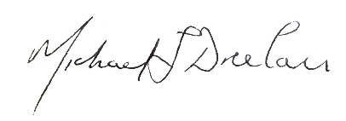
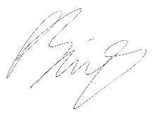

Name: Councillor Prad Bains Name: Cdr Michael Dreelan RN
Position: Mayor of Havant Position: Naval Base Commander (Portsmouth) Executive Officer
Date: 01 02 2021 Date: 01 02 2021
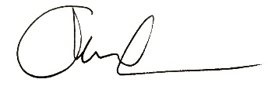

Name: Lt Col Christopher Lane MBE RA
Position: CO 16th Regt Royal Artillery
Date: 01 02 2021
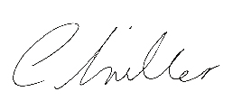

Name: Wg Cdr Chrissie Miller MA RAF
Position: CO RAF (U) Swanwick
Date: 01 02 2021

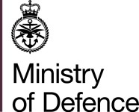

The Armed Forces Covenant

An Enduring Covenant Between
The People of the United Kingdom
Her Majesty’s Government
- and –
All those who serve or have served in the Armed Forces of the Crown
And their Families

The first duty of Government is the defence of the realm. Our Armed Forces fulfil that responsibility on behalf of the Government, sacrificing some civilian freedoms, facing danger and, sometimes, suffering serious injury or death as a result of their duty. Families also play a vital role in supporting the operational effectiveness of our Armed Forces. In return, the whole nation has a moral obligation to the members of the Naval Service, the Army and the Royal Air Force, together with their families. They deserve our respect and support, and fair treatment.

Those who serve in the Armed Forces, whether Regular or Reserve, those who have served in the past, and their families, should face no disadvantage compared to other citizens in the provision of public and commercial services. Special consideration is appropriate in some cases, especially for those who have given most such as the injured and the bereaved.

This obligation involves the whole of society: it includes voluntary and charitable bodies, private organisations, and the actions of individuals in supporting the Armed Forces. Recognising those who have performed military duty unites the country and demonstrates the value of their contribution. This has no greater expression than in upholding this Covenant.

Section 1: Principles of The Armed Forces Covenant

  - We Havant Borough Council, will endeavour in our business dealings to uphold the key principles of the Armed Forces Covenant, which are:

- Members of the Armed Forces community experience no disadvantage as a result of their service in the Armed Forces;
- Appropriate actions are taken to support the transition from military to civilian life;
- Work with partners to reduce duplication and ensure efficient and effective use of all available resource to deliver the best possible outcomes for the members of the local armed forces and civilian communities:

Section 2: Demonstrating our Commitment

2.1 Havant Borough Council recognises the value serving personnel, reservists, veterans and military families bring to our organisation. We will seek to uphold the principles of the Armed Forces Covenant, by:

- Promoting the fact that we are an Armed Forces-friendly organisation;
- Seeking to support the employment of veterans young and old and working with the Career Transition Partnership (CTP), in order to establish a tailored employment pathway for Service Leavers;
- Striving to support the employment of Service spouses and partners;
- Endeavouring to offer a degree of flexibility in granting leave for Service spouses and partners before, during and after a partner’s deployment;
- Seeking to support our employees who choose to be members of the Reserve forces, including by accommodating their training and deployment where possible;
- Offering support to our local cadet units, either in our local community or in local schools, where possible;

2.2 We will publicise these commitments through our literature and/or on our website, setting out how we will seek to honour them and inviting feedback from the Service community and our customers on how we are doing.

2.3 Havant Borough Council have set priorities to include:

- Recognising and remember to support and attend remembrance events including Armed Forces Day across the Borough;
- Health and wellbeing – ensure information is relevant and accessible relating to housing, communication and support services (via a signposting service)
- Employability and education – support veterans and their families to identify education opportunities and maximise their employability
- Economic development – the council will advocate the Defence Employer Recognition Scheme by encouraging other employers to engage in the scheme.
- Leisure and recreation – the council will promote sport and physical activity related programmes and initiatives and encourage the use of and promote open space, leisure facilities and health related programmes to the Armed Forces community.

2.4 Havant Borough Council Covenant Output Action Plan:
This Covenant will provide the opportunity to work more strategically and collaboratively with the Armed Forces community. This work will be driven through the Covenant action plan.

In addition to addressing the key priorities, the Covenant will ensure:

- Robust communication channels maintained between the Armed Forces community and Havant Borough Council
- At least once a year, the signatories will review the measures they are taking to implement the principles of the Armed Forces Covenant and consider if further actions would be helpful
- Havant Borough Council is firmly committed to equality and diversity. We endeavour to ensure fairness for all and pay particular attention to:
      - Eliminate unlawful discrimination, harassment, victimisation and any other conduct that is prohibited by or under the Equality Act 2010.
      - Advance equality of opportunity between persons who share a protected characteristic and those who do not and;
      - Foster good relations between persons who share a protected characteristic and those who do not share it.

