HAMPSHIRE COUNTY COUNCIL
NOTICE OF VACANCY

FOR A COUNTY COUNCILLOR IN THE

PURBROOK AND STAKES SOUTH

COUNTY ELECTORAL DIVISION

NOTICE IS GIVEN that, following the resignation of Councillor Gary Hughes a vacancy exists for a County Councillor in the Purbrook and Stakes South County Electoral Division.

Any two local government electors for the administrative area of Hampshire are entitled to require an election to fill the vacancy to be held within 35 days (excluding Saturdays, Sundays and Bank Holidays). Requisitions for this purpose, including your full postal address, should be sent to the County Returning Officer, The Castle, Winchester, Hampshire, SO23 8UJ.

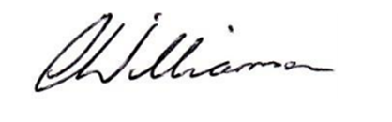
Carolyn Williamson
County Returning Officer
The Castle
Winchester
Hampshire
SO23 8UJ

Date: 16 March 2023

