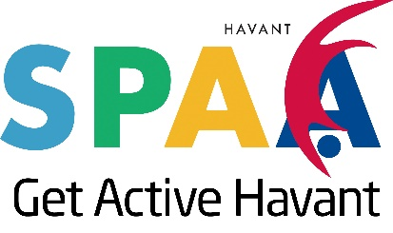

SPAA Grant Funding Guide and Application Form
2019/2020

Deadline for submission: 5pm on 28 May 2019

SPAA Grant Funding Guide.
SPAA Grant
This guide forms part of the funding application and outlines the funding criteria associated with the SPAA Grant. The SPAA Grant is open to SPAA members.
Below sets out the criteria for the SPAA Grant;
- Open to SPAA members
- Total SPAA grant funding pot of £2000
- Applications must evidence partnership work with at least one other SPAA member
- Must benefit residents of Havant Borough and be spent within the borough
- Applicants must evidence an overall aim of increasing sport, physical activity and health and wellbeing opportunities
- Grants can be spent on capital or revenue funding
- Grants cannot be used for existing running costs but can be used to enhance existing projects
- 50% match funding required, this can be in kind or cash value
- Closing date for applications is 5pm on 28 May 2019
- Applications will be evaluated by 7 June 2019 and all applicants will be notified of the decision following this date
- Awarded grants must be allocated and paid by 31 March 2020
- Sport and Leisure Officers are available to develop and support project ideas

Deadline for submission of grant application forms is 5pm on 28 May 2019 please email your completed application to matthew.tyler@havant.gov.uk

SPAA Grant Funding Application Form.

Step 1: About the organisations applying

Lead Organisation name:
Lead Organisation point of contact:
Partner Organisation(s):

Step 2: About your project

1) What is the title of your project?

2) Is this a new project or will the funding be utilised to enhance an existing project?

3) Will this project benefit Havant Borough residents? (delete as appropriate)

Yes No

4) How much funding are you applying for?

5) In 250 words describe your project.
Tell us everything we need to know, how will this increase sport, physical activity and health and wellbeing opportunities? What is the target audience? How many participants will the project look to engage with?

6) Where will your project take place?
Be specific.

7) Tell us why your project is needed? (250 words)
Tell us why your project needs to happen? Have you engaged with the audience in the design of this project? Provide evidence of need.

8) Please evidence how you will match fund this project?
Match funding can be in kind or as a financial contribution, please provide a breakdown of match funding, officer time etc.

9) What are your project delivery dates?

10) What happens when your project ends? (250 words)
Is your project sustainable? What exit routes are available to participants?

Thank you for taking time to review the questions set out in the SPAA Grant application form, as with any funding stream this is a competitive process and funding cannot be guaranteed.

Deadline for submission is 5pm on 28 May 2019 please email your completed application to matthew.tyler@havant.gov.uk

